

Final Report for Twitch

Game Recommendation System

**TIM 158 - Group 4**

Ali Ahmed, Alex He, Jose Iglesia, Justin Jaunay

Nicholas Jurgens, Anjali Kanthilal, Hongni Liu

# Table of Contents

Executive Summary……………………………………………………………………… Page 3

Introduction………………………………………………………………………………... Page 4

Traditional Data Center Architecture for Twitch………………………………………… Page 5- 28

Software-Defined Infrastructure for Twitch: Virtualization and cloud Computing……. Page 29- 39

Machine Learning Problem solved within the context of the traditional DC and/or SDI.Page 40- 55

Conclusion…………………………………………………………………………………. Page 56

# Executive Summary

# Twitch is one of the world's leading video game platforms used by many gamers to socially communicate and connect to watch gamers play against each other. Essentially it is a community of gamers who gather to watch and talk about their favorite video games, latest trending, and the most popular. It has over 9.7 million daily active users, 2+ million unique streamers per month, 17+ thousand members of the Twitch Partner Program, 106 minutes watched per person per day, 2+ million peak concurrent sitewide viewers, 46+ million raised by the Twitch community for charity. (https://www.twitch.tv/p/about). Within the gamer community, gamers tend to watch people who are highly skilled at certain games to learn a few techniques and moves that could benefit them. Every game imaginable is on twitch and streamers actually make living based on how well the interact with their viewers.

# Twitch is a very successful company yet our team has looked into making this company even more successful and profitable. As a team we brought up the idea of finding a better way to increase the user viewership. By doing such improvements it will would help both gamer and streamer. Our team has learned a great deal about the gaming industry, we believe that twitch is a very unique and dynamic company and the changes that we have made will profit the company.

# 

# Introduction

Phase 1 deliverables allowed our team to build a traditional IT data center infrastructure for Twitch. The first 5 steps of this phase shows us how to solve our end goal of giving Twitch Channel Recommendations. Step 1 showed helped us identify what our largest issue was and create use cases to help narrow the problem. In Step 2, we created a Client-Server Software/Hardware Architecture Design for Twitch. Here we created a FAST diagram which helps us identify the different layers and tiers of Twitch. For Step 3, we created the Database Design for Twitch. This helped us find the different databases we would need, create entity relationship diagrams, and find potential DBMS and storage vendors. In Step 4, we created the Network Architecture for Twitch. This helped us understand how Twitch works at its core, at the four primary layers and how information flow works. Step 5 allowed us to create an end to end integrated IT architecture for Twitch connecting the previous 3 steps of client-server architecture, DBMS, storage and network architecture. And lastly, step 6 allowed us to once again choose our main problem at hand- Twitch Channel Recommendations, and gather information to help us create a better recommendation system.

# Traditional Data Center Architecture for Twitch

# **Software Requirements and Vendor selection for Twitch**

1. Key Business Problem
   1. Business Problem
      1. The business challenge that our group plans to resolve is that Twitch needs to improve channel recommendations.
         1. Record user history
            1. Record user information
            2. Track subscriptions
            3. Track active channels
            4. Track users on channel

Recommended channels

1. Requirements for each business process.
   1. Record user history
      1. Data storage system
      2. Rails
      3. Go
      4. Various open-source applications
   2. Record user information
      1. Data storage system
      2. Web APIs
   3. Track subscriptions
      1. Web APIs
      2. Data storage system
   4. Track active channels
      1. Rails
      2. Go
      3. Various open-source applications
   5. Track users on channel
      1. Track the users currently watching the channel, and use their collective history of watching different channels to recommend channels.
      2. The community as a whole probably enjoy watching similar things and therefore would be a good point of access into improving our business problem
2. Develop use cases for these business processes.
   1. Streamers
      1. Play live video games
      2. Live cast video games
      3. Upload game videos
   2. Users
      1. Watch video
      2. Comment on video
      3. Change videos
   3. System process (website)
      1. receives videos
      2. Store videos in the database (storage)
      3. Post videos online
   4. Access video website through web browser
   5. Click on the video (send “watch video” request)
   6. (website) receive request and load video from file system (database)
   7. Watch video

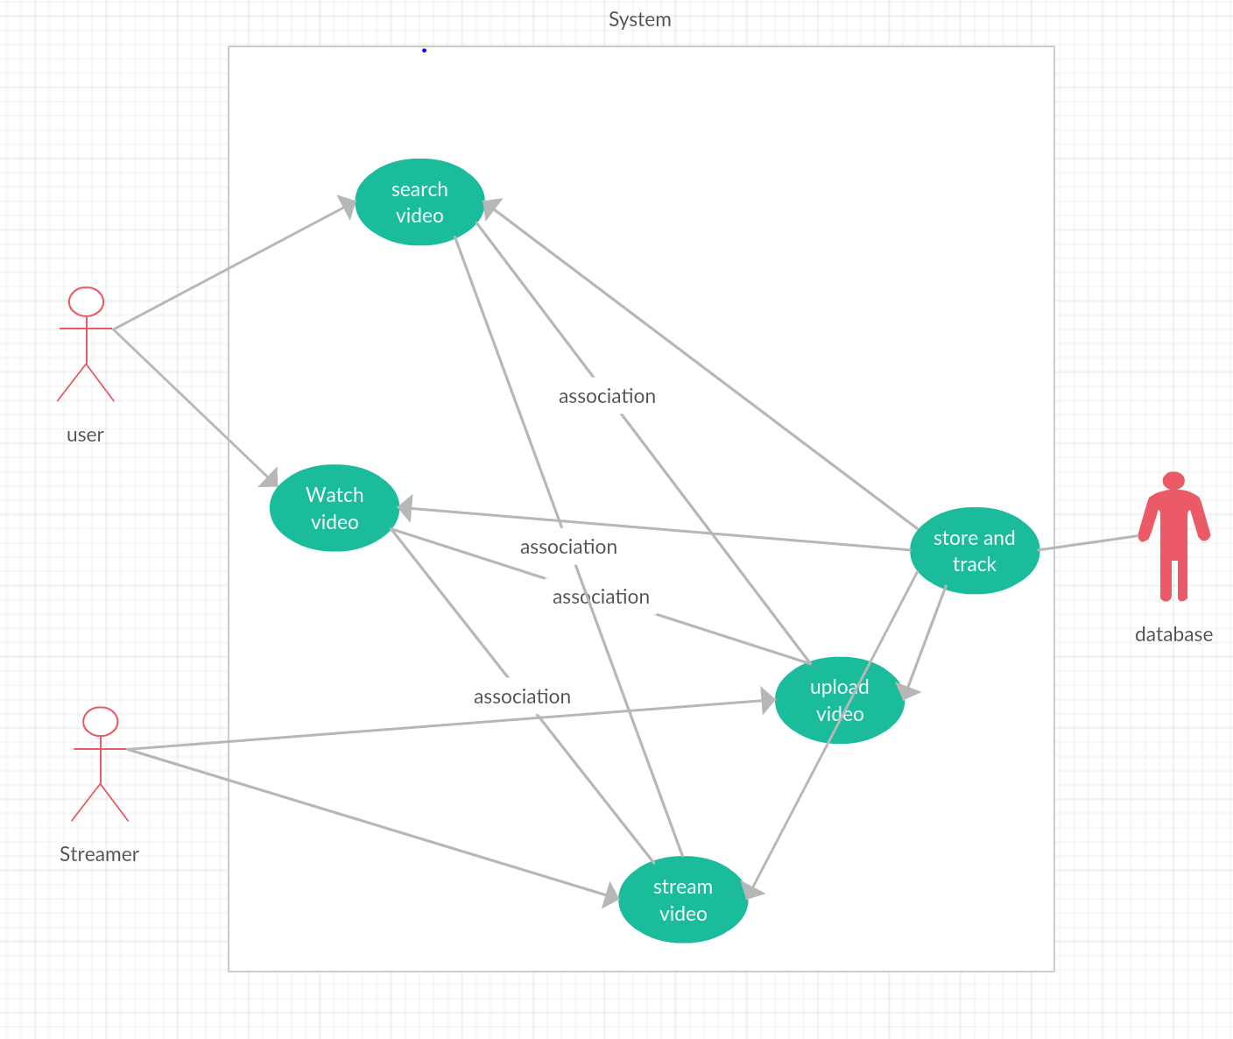

1. Use the use-cases to check the list of software requirements found in step 1.2.
   1. Enable the GUI (Graphic User Interface) for the client on the client’s computer
   2. Present the client necessary information (Categories of videos, etc)
      1. Creates the GUI for the client
      2. Enables visualization, data entry, communication with the application & output of results
   3. Provides the application logic
      1. User Logic
         1. User information
         2. Watching various twitch videos
         3. Uploading videos to Twitch
      2. Video Processing and Storage Logic
         1. Transcode Video
         2. Store Videos at Amazon Data Warehouse
         3. Retrieve Videos from Amazon Data Warehouse
   4. Manipulate and Store data
      1. User video
   5. Store and track
      1. Track user search: When a user searches on Twitch to find videos that interest them the database will record and track to eventually be used to recommend different channels
      2. Track user video watches: When a user watches a video on Twitch the database will record and track to eventually use the information to recommend channels that are similar to the videos that have been watched
      3. Track streamer upload and Streaming: track the content of the video then store and track to use this information to recommend channels that are similar to the content of the cvideo

**Client-Server Software/Hardware Architecture Design for Twitch**

1. Perform research on Twitch and create a FAST diagram
   1. How it works
      1. Twitch is an online site that allows users to watch or broadcast live streaming or pre-recorded video of broadcaster's video game gameplay.
      2. Once you're signed up, you get your own user page, called a channel, with your chosen user ID as part of the URL (in the form [www.twitch.tv/username](http://www.twitch.tv/username)).
      3. The basic hardware elements necessary for broadcasting to Twitch are a computer or gaming console running the right software, and a good broadband Internet connection. If you want to include video of yourself and audio commentary, a webcam and microphone (even just your built-in computer microphone) are necessary.
      4. Recommended system specifications for broadcasting Twitch from a PC:
         1. At least an Intel Core i5-4670 or AMD equivalent CPU
         2. At least 8 gigabytes (GB) of DDR3 SDRAM memory
         3. Windows 7 Home Premium or later OS
         4. A GPU that supports DirectX 10 and up
      5. Twitch also offers an API to help web developers integrate Twitch content and functionality into their sites and web applications.
      6. Twitch is monetized via advertising and subscription fees.
   2. System/Subsystems
      1. System -> Twitch
      2. Subsystems
         1. Video System:
            1. Video ingest
            2. Transcode system
            3. Distribution and Edge
            4. VOD system
         2. Chat
            1. Edge
            2. Pubsub
            3. Clue
            4. Room
         3. Web APIs/Data
            1. Search and Discovery
            2. Revenue Systems
            3. Administrative tools
         4. Web/Client Applications
            1. Desktop web application
            2. Native apps
            3. Console Applications
         5. Data Science Infrastructure
            1. Data pipeline
            2. Streaming Aggregators
         6. Tools/Operational Infrastructure
            1. Manual/Automatic QA
            2. Monitoring/Alerting systems
            3. Distributed Trace
   3. Primary/Sub-functions

|  |  |
| --- | --- |
| **Sub-System** | **Sub-Functions** |
| Video System | The video system is responsible for getting video from the broadcaster to the viewers. |
| Chat | Chat is a highly scalable real-time distributed system written in Go. It delivers hundreds of billions of messages per day to users who are watching video via Twitch protocols, as well as supporting IRC as a communication protocol, making it easy for developers to create IRC bots to add their own custom chat features. |
| Web APIs/Data | Web APIs allow users to manage and customize their profiles and subscriptions. |
| Web/Client Applications | Client applications aim at making it easy to use Twitch as well as enabling all of the services they offer |
| Data Science Infrastructure | Science Engineering builds data collection systems and analysis tools to study how Twitch users interact with the products. |
| Tools/Operational Infrastructure | Include tools to help manage the services they have for the application and product. |

* + 1. Primary function
       1. Twitch is an online site that allows users to watch or broadcast live streaming or pre-recorded video of broadcaster's video game gameplay.
  1. HOWs and WHYs

|  |  |
| --- | --- |
| **HOW** | **WHY** |
| Video Ingest | Video System |
| Transcode System |
| Distribution and Edge |
| VOD System |
| Edge | Chat |
| Pubsub |
| Clue |
| Room |
| Search and Discovery | Web APIs/Data |
| Revenue Systems |
| Administrative Tools |
| Desktop Web Applications | Web/Client Applications |
| Native Apps |
| Console Applications |
| Data Pipeline | Data Science Infrastructure |
| Streaming Aggregators |
| Manual/Automatic QA | Tools/Operational Infrastructure |
| Monitoring/Alerting Systems |
| Distributed Trace |

* 1. FAST Diagram

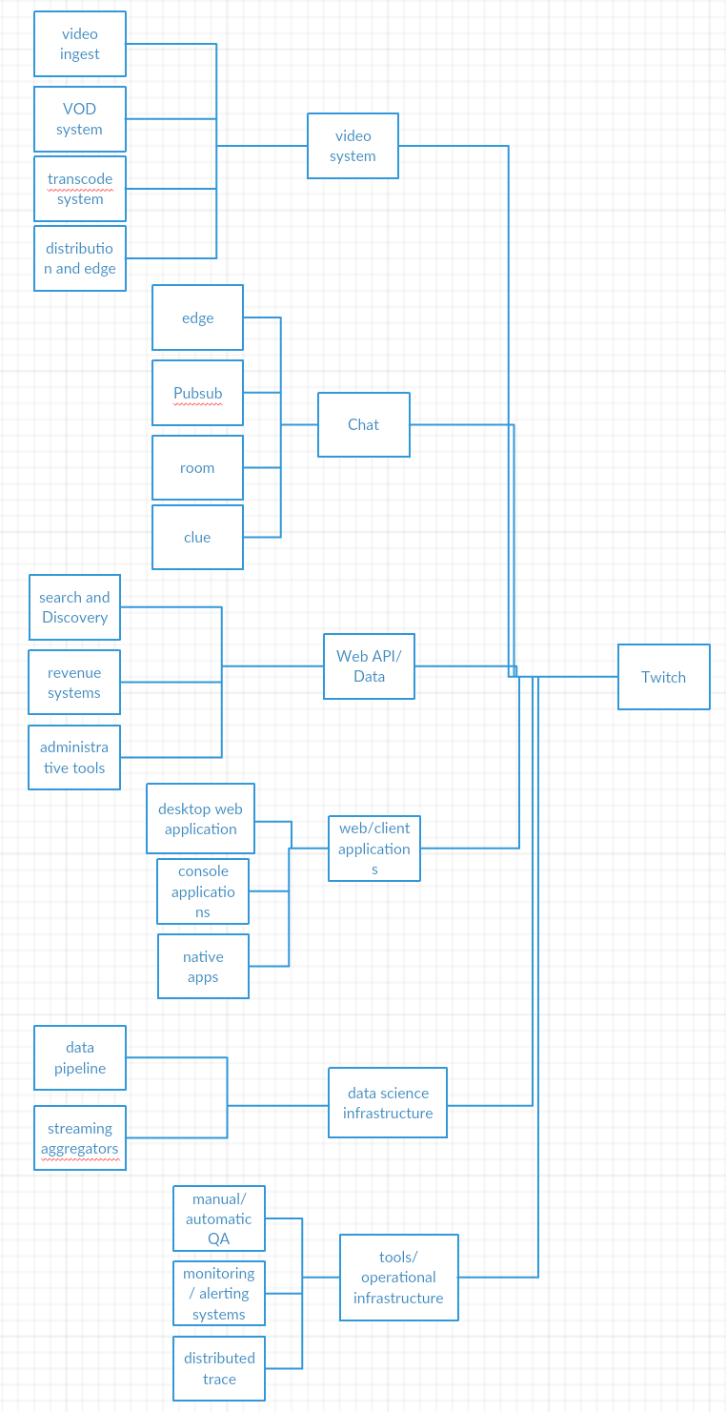

1. Design the client server software and hardware architecture to solve Twitch’s key business problem
   1. Software Architecture
      1. Layer 1: Enable the GUI (Twitch Application) for the client on the client’s pc/device.
      2. Layer 2: Present the necessary information: Channel recommendations, live videos, broadcasting, chat, etc..)
      3. Layer 3: Application Logic
         1. User Logic
         2. Steamer Logic
         3. Business Logic
      4. Layer 4: Manipulate and Store Data
         1. User Logic
            1. Customer information
            2. Watching a stream
            3. Subscribing
            4. Making donations
            5. Chat
         2. Steamer Logic
            1. Upload Videos
            2. Stream Videos
            3. Accept donations
         3. Business Logic
            1. Manage account information
            2. Manage bank information
            3. Moderate user and streamer
      5. Software architecture diagram

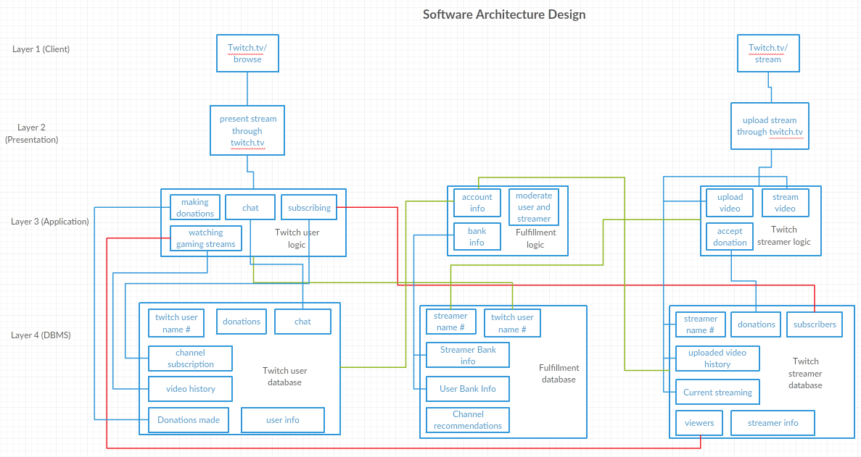

* 1. Hardware architecture

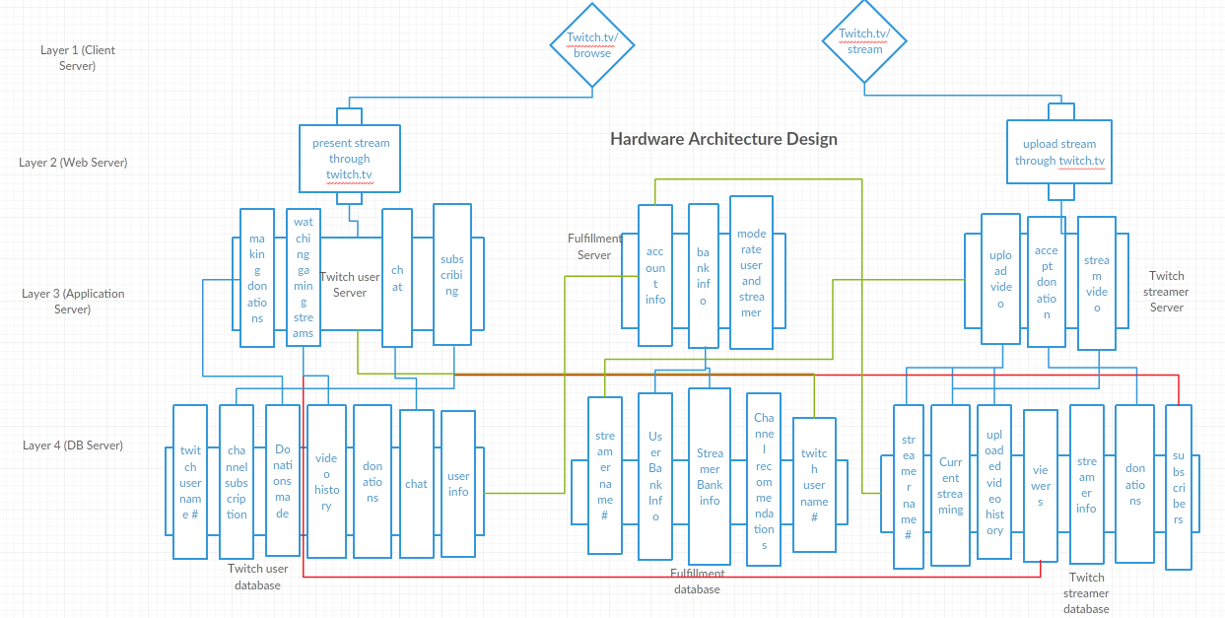

* 1. Software and Hardware Vendor Alternatives
     1. Layer 1: Client
        1. Software Options: Users can choose between different web browsers or use the mobile application.
        2. Hardware Options: This is the users choice of device: PC, mobile phone, etc.
     2. Layer 2: Presentation
        1. Software Options:
           1. Mobile Phone: Appery.io, Mobile Roadie, The AppBuilder, Good Barber
           2. PC: Wix, Weebly, Squarespace, Strikingly
     3. Layer 3: Application
        1. Vendors for Software: Microsoft, Oracle, SAP
        2. Hardware Options: Dell PowerEdge T20[barebones], Dell PowerEdge T20[Xeon], Lenovo ThinkServer TS140, Supermicro SuperWorkstation 5039A-IL
     4. Layer 4: Database Management System
        1. Vendors for software: Oracle, IBM, Microsoft
  2. Selection Criteria
     1. Layer 2: Presentation
        1. Ease of Use
        2. Customization
        3. Platform Support
        4. Accessibility
        5. Reliability
     2. Layer 3: Application
        1. For application software vendor we want a product that can cover any and all department within the organization.
        2. We want the application to be scalable to be able to accept any excess traffic and streaming on our website
     3. Layer 4: Database Management System
        1. We want a software that allows our programmers to have a systematic way of creating, retrieving, updating, and managing data.
           1. While users and streamers are actively using the website
  3. Best Vendor
     1. Layer 2: Presentation
        1. Mobile Phone: Using the criteria chosen in the previous step, the best vendor choice would be Appery.io. This is because the app builder can be used to create apps for multiple platforms (Android, iOS, and Windows Phone). Also the builder runs in the cloud making it easy to start. Most importantly collaboration is simple, allowing you to share the mobile project with development teams and business users in real time.
        2. PC: From the table below we can see that Weebly seems to be the best website vendor to use.

|  |  |  |  |  |
| --- | --- | --- | --- | --- |
| Information | Wix | Weebly | Squarespace | Strikingly |
| Ease of Use | 92% | 94% | 92% | 88% |
| Number of Templates | 500+ | 18 | 60 | 40 |
| Analytics Score | 73% | 100% | 100% | 100% |
| Storage | 10GB | Unlimited | Unlimited | Unlimited |
| Free Custom Domain | Yes | No | No | No |

* + 1. Layer 3: Application
       1. Software Choice
          1. Below is an image that compares the three software vendors. We can see that Microsoft has the most options and appears to be the best choice.

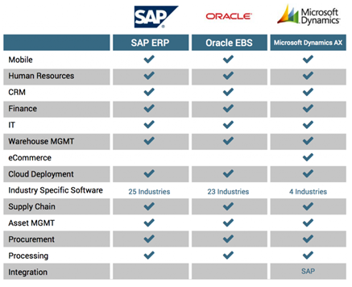

* + 1. Hardware Choice
       1. From the list of different smb choices and based off of the table below we chose the Supermicro SuperWorkstation 5039A-IL. This smb server has a load of upgrade space and potential. It also has support for up to eight hard drives.

|  |  |  |  |  |  |  |
| --- | --- | --- | --- | --- | --- | --- |
| **SMB Server** | **CPU** | **Graphics** | **RAM** | **Storage** | **Connectivity** | **Dimensions** |
| Dell PowerEdge T20[barebones] | Intel Pentium G3220 | Intel HD Graphics | 4GB | No drives included | Up to 12 x USB ports (4 x USB 3.0), 2 x DisplayPort, VGA, serial, 2 x PS2, Gigabit Ethernet | 17.5 x 43.5 x 36cm |
| Dell PowerEdge T20 [Xeon] | Intel Xeon E3-1225 v3 | Intel HD Graphics P4600 | 32GB | 1TB HDD | Up to 12 x USB ports (4 x USB 3.0), 2 x DisplayPort, VGA, serial, 2 x PS2, Gigabit Ethernet | 17.5 x 43.5 x 36cm |
| Lenovo ThinkServer TS140 | Intel Xeon E3-1226 v3 | Intel HD Graphics P4600 | 4GB | 2 x 1TB HDD | 9 x USB 2.0, serial, video, 2 x DisplayPort, audio, Gigabit Ethernet | 17.5 x 42.5 x 43cm |
| Supermicro SuperWorkstation 5039A-IL | Intel Xeon E3-1200 v5 | Intel HD Graphics P530 | 64GB | No drives included | 6 x USB 3.0, 8 x USB 2.0, 2 x USB 3.1, 7.1 audio, HDMI, DVI-D, DisplayPort, 2 x Gigabit Ethernet | 19 x 52.5 x 42.5cm |

* + 1. Layer 4: Database Management System
       1. The database management vendor to choose for this situation is Microsoft SQL Server. This is because our application layer is also using Microsoft. Microsoft SQL Server also provides enterprise-class data management and integrated business intelligence tools. SQL Server provides impressive performance for mission-critical applications, using in-memory technologies, faster insights from any data to any user in familiar tools.

**Database Design for Twitch**

1. Databases
   1. Streamer DataBase

|  |  |  |  |  |  |  |
| --- | --- | --- | --- | --- | --- | --- |
| Steamer name #(primary key) | Donations | Subscribers | Uploaded Video history | Current Streaming | Viewers | Streamer info |
|  |  |  |  |  |  |  |

* 1. User Database

|  |  |  |  |  |  |
| --- | --- | --- | --- | --- | --- |
| User name  #(primary key) | user info | chat | Channel subscriptions | video history | Donations made |
|  |  |  |  |  |  |

* 1. Fulfillment Database

|  |  |  |  |
| --- | --- | --- | --- |
| Name #(primary key) | Streamer bank info | User bank info | Channel recommendation |
|  |  |  |  |

1. Entity Relationship Diagram

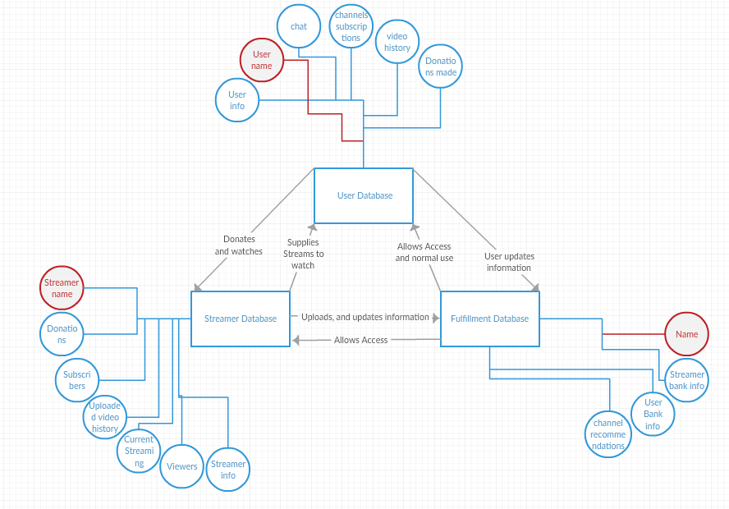

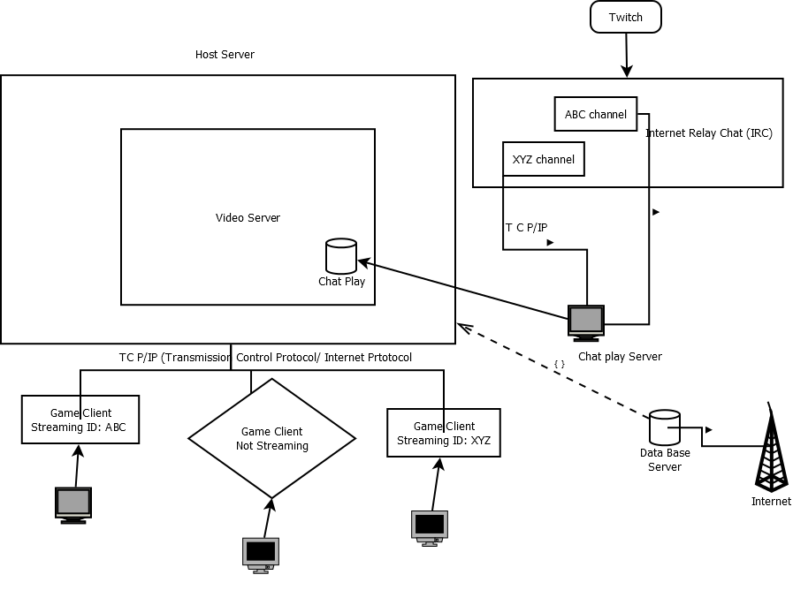

1. Operations to Solve the Problem
   1. DBMS Vendor Options
      1. How many DB servers?
         1. User Database
         2. Streamer Database
         3. Fulfillment Database
      2. Functionality of each server?
         1. User Database
            1. The User database servers stores all of the information pertaining to the user. This gives Twitch an idea of how active the user is and what types of videos they’re watching.
         2. Streamer Database
            1. The Streamer database servers store any information pertaining to the streamer. This includes viewer count, subscribers, uploads, etc. This allows Twitch to gauge how popular a streamer is and what type of content they have. This helps them make decisions on whether they want to give them a Twitch contract.
         3. Fulfillment Database
         4. The fulfillment database servers contain all of the bank details for each twitch user and streamer. This allows them to process donations as well as pay for some twitch partners. They also store channel recommendations for each user.
         5. Vendor
            1. Vendor Options

Oracle Database

Microsoft SQL Server

IBM DB2

SAP Sybase ASE

PostgreSQL

MySQL

* + - * 1. Vendor Choice

Microsoft SQL Server

Ease of Use

Excellent tools for development and troubleshooting

1. Storage Requirements
   1. Most of Twitch’s data storage requirements come from archival, sequential, and random storage.
   2. Archival Storage:
      1. Watch history
      2. Chat History
      3. Activity History
      4. Archived Videos
   3. Sequential and Random Storage:
      1. Current streaming
      2. Current chat
      3. Bandwidth updates
      4. Tracking donations
2. Define the storage requirements.
   1. Video server will need load balancers for unexpected server crashes.
   2. Video Database must have enormous storage space for saved videos.
   3. DBMS Server must be capable of storing and quickly accessing user information.

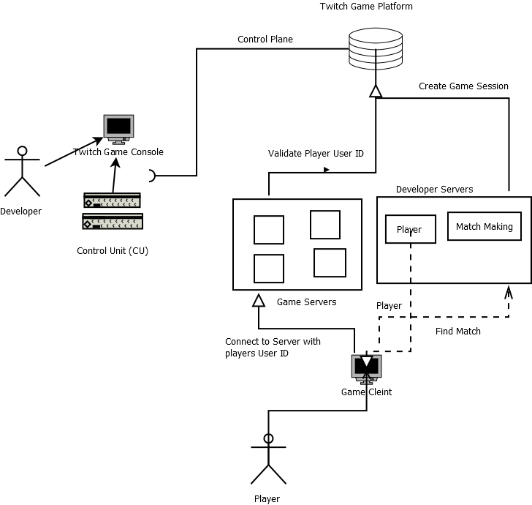

**Network Architecture for Twitch**

1. Define the network devices that are needed
   1. Routers & switches
   2. Load balancers
   3. Firewalls
2. Map the requirements to the devices.

|  |  |  |  |
| --- | --- | --- | --- |
| Requirements | Routers & switches | Load balancers | Firewalls |
| Scalability | X | X |  |
| Reliability |  | X |  |
| Security |  |  | X |
| Agility | X | X |  |

1. Based on the layering of the IT architecture, define a set of subnets.
   1. Web server layer Web Server subnet
   2. Application server layer Application Server subnet
   3. DB server layer DB server subnet
2. For each subnet, determine the network topology to connect the servers in the subnet using switches (& routers).
   1. Web Server Network Topology

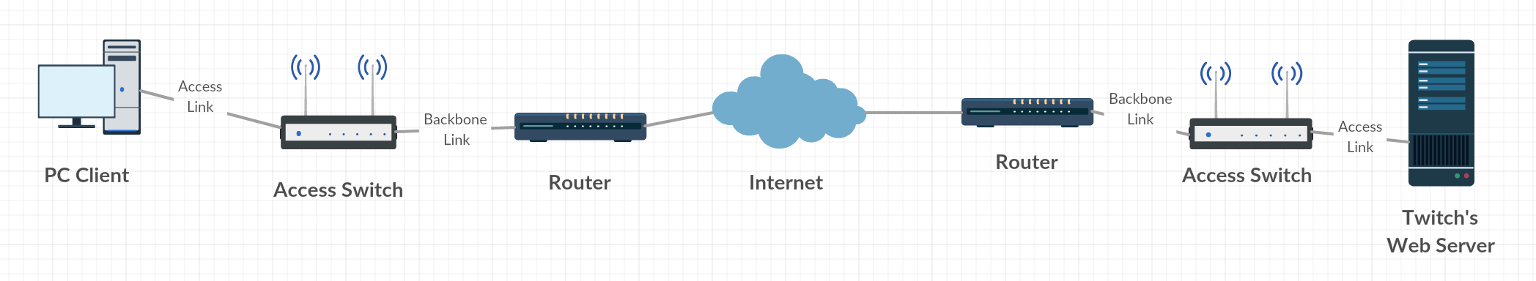

* 1. The PC client is connected to Twitch’s web servers through an assortment of routers and switche s, It has the internet in the very center of the Topology. This is because a user should be able to access the website from anywhere.

1. Application Server Network Topology

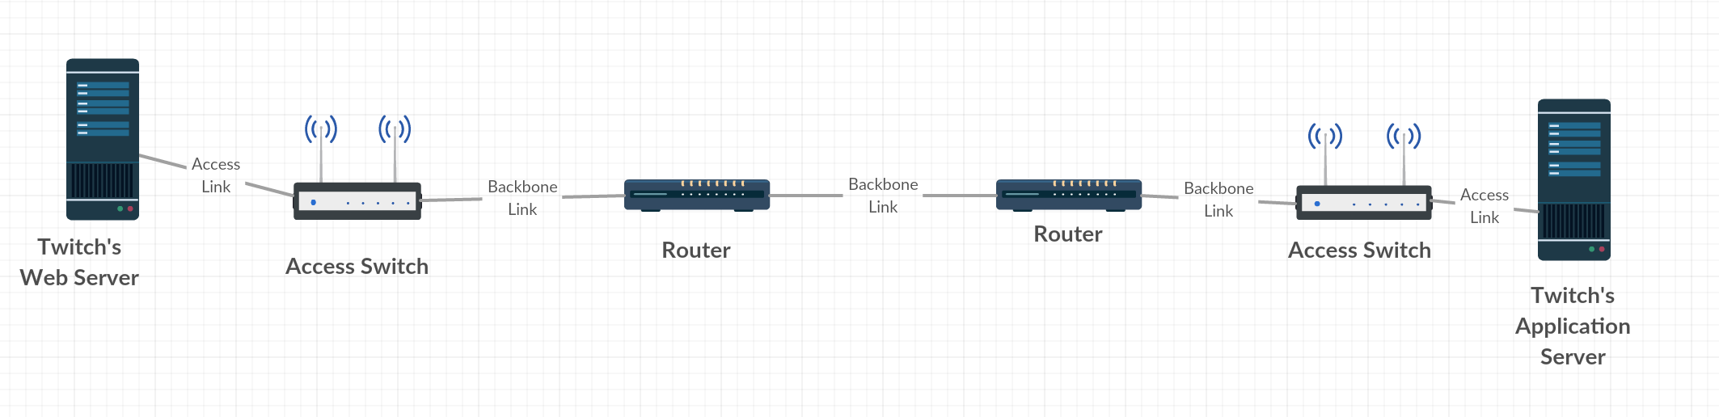

* 1. Twitch’s Web server is connected to the Twitch’s Application server through a series of routers and switches. It does not have the internet in between it because Twitch’s web server needs to be more secure on the application end.

1. DB Server Network Topology

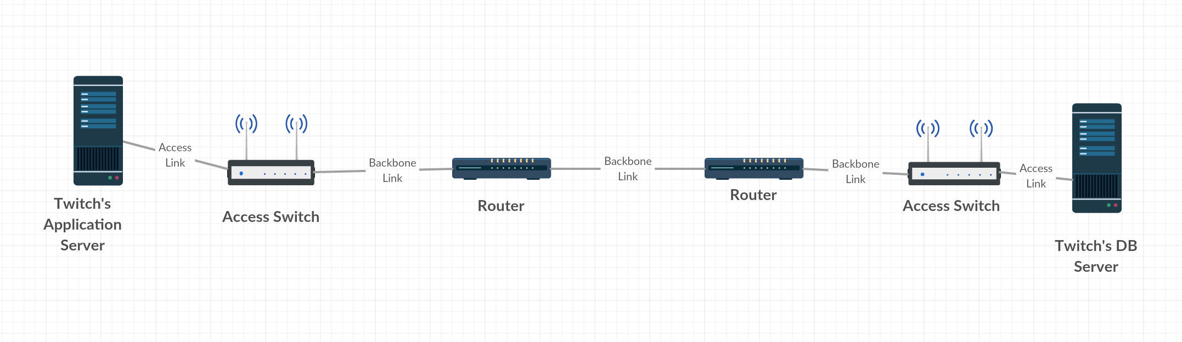

* + 1. Twitch’s application server and Twitch DB server are separated by routers and switches because they need to be in relative close vicinity.

1. Connect between the subnets using routers & switches to achieve the n-tier architecture.

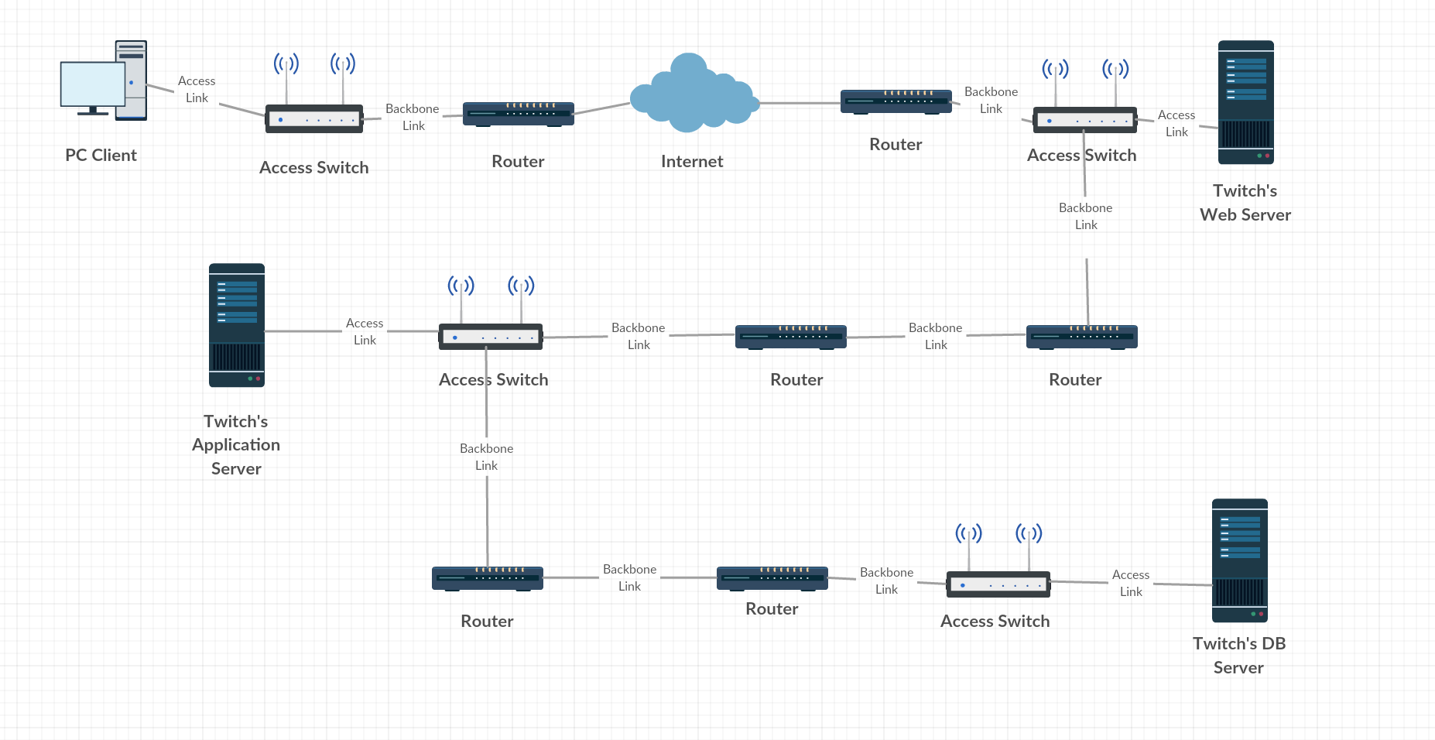

* 1. Once everything is connected we have a fuller picture of what the network looks like.

1. Add load balancers for each layer of the architecture.

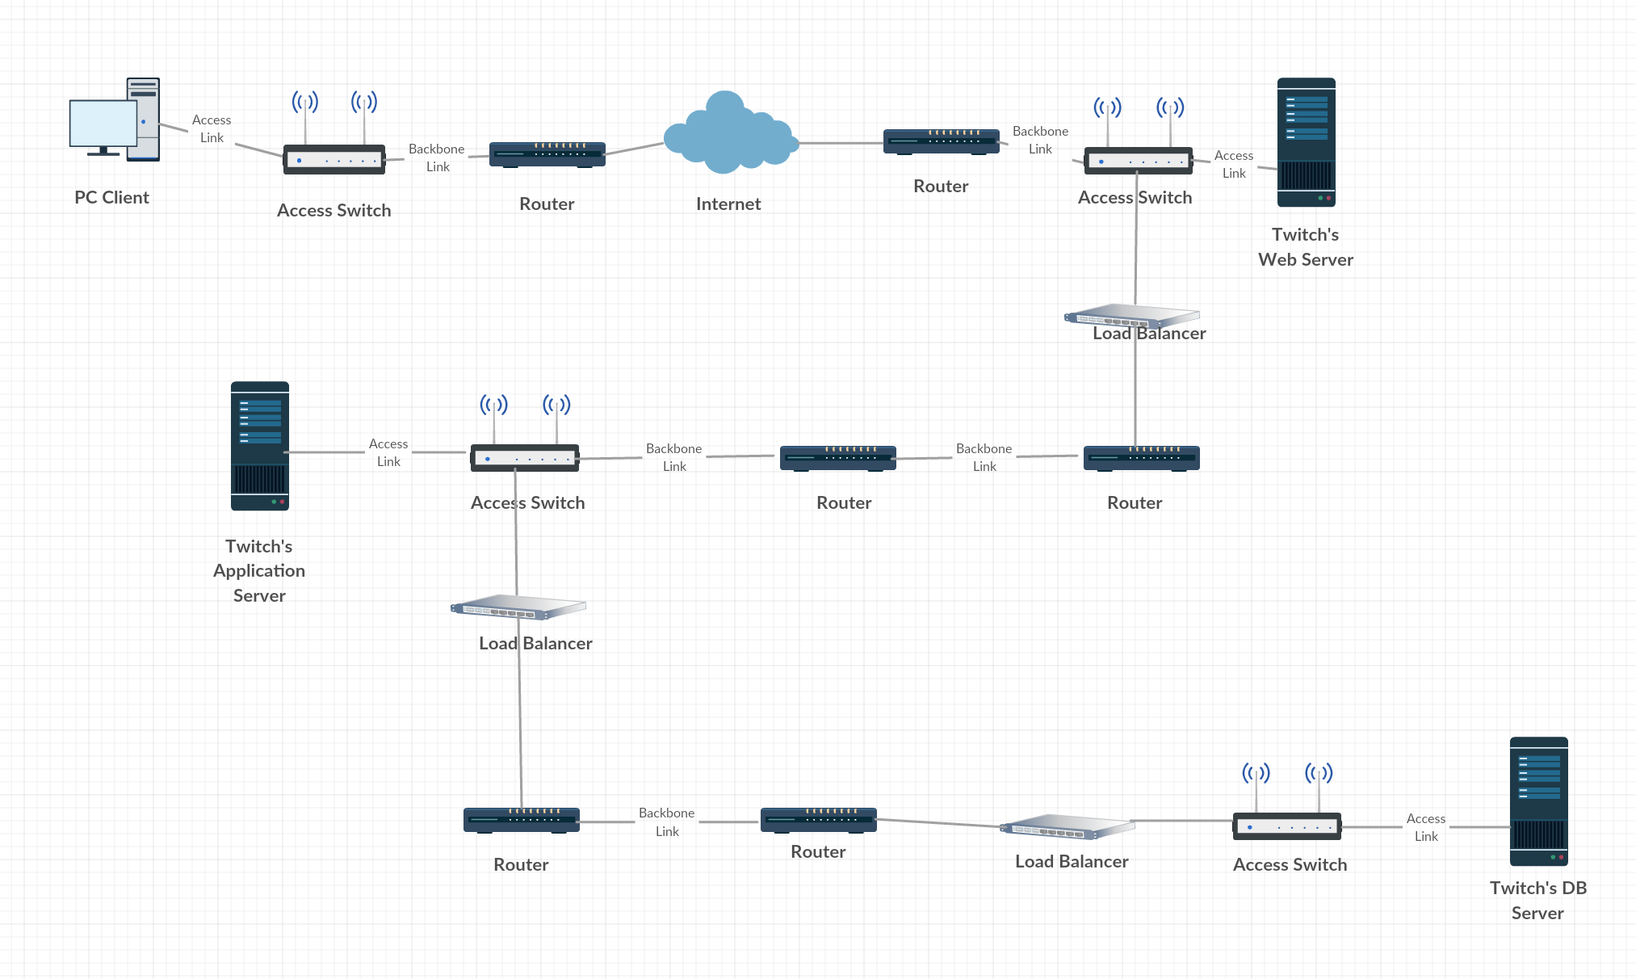

* 1. Load balancers are added into each layer of the architecture, and this is done so that Twitch’s can get surges in bandwidth and still maintain a reliable network topology.
  2. They are added in between the web server and the application server so that if there is an excess of bandwidth demand coming from users the load balancer will help handle the pressure
  3. They are added in between the Application server and the Database server so that if there is an excess of bandwidth demand coming from a problem with the application server. The load balancer will handle some of the excess pressure

1. Add firewalls for each layer of the architecture.

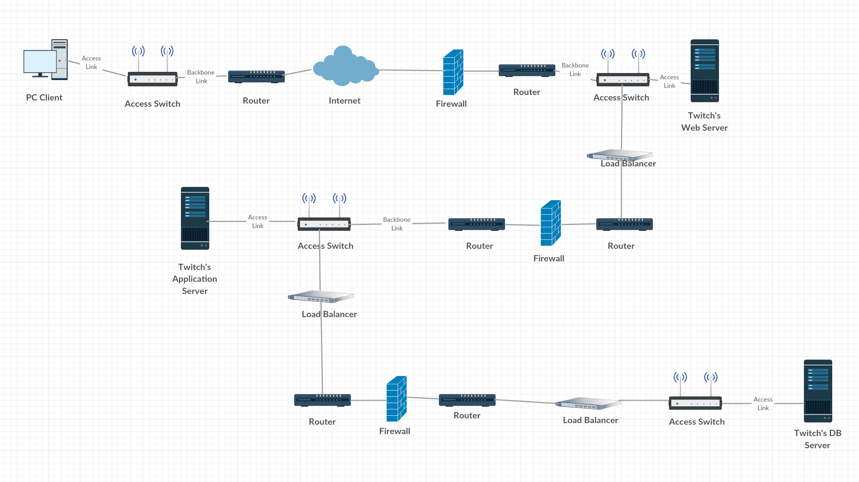

* 1. Firewalls are added into the topology to block unauthorized access while permitting outward communication.
  2. They are placed at 3 different layers because breaches can occur at each layer of the topology.

**IT Integration for Twitch**

1. Twitch Network Topology
   1. Basic network topology for tier Client server

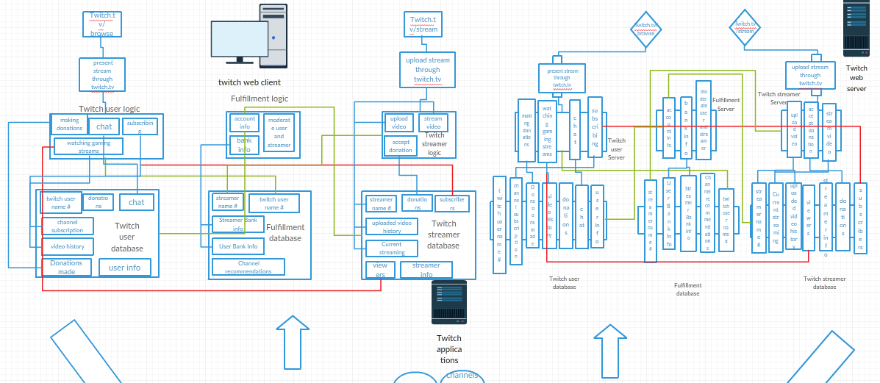

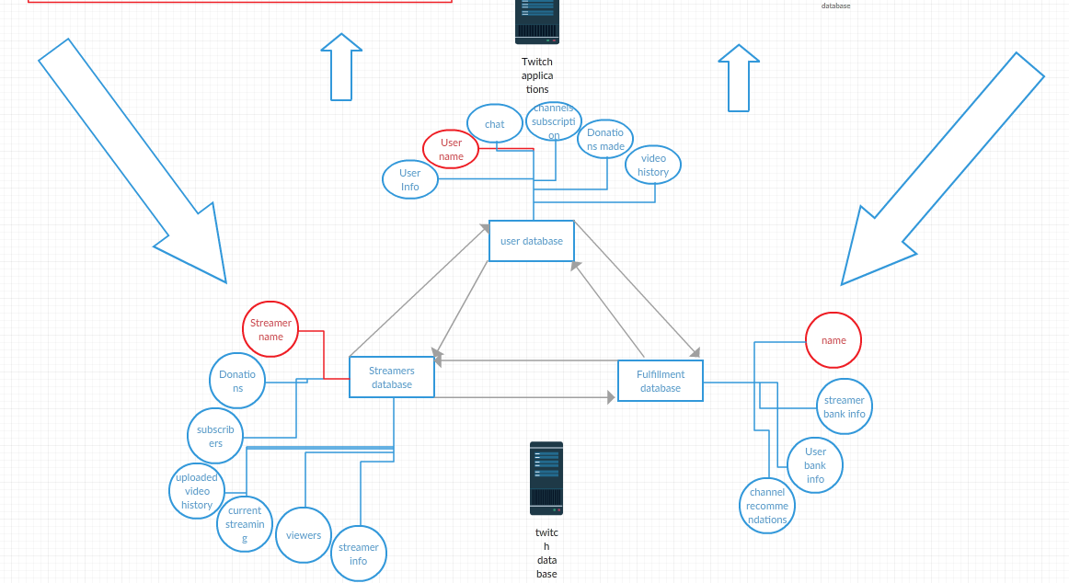

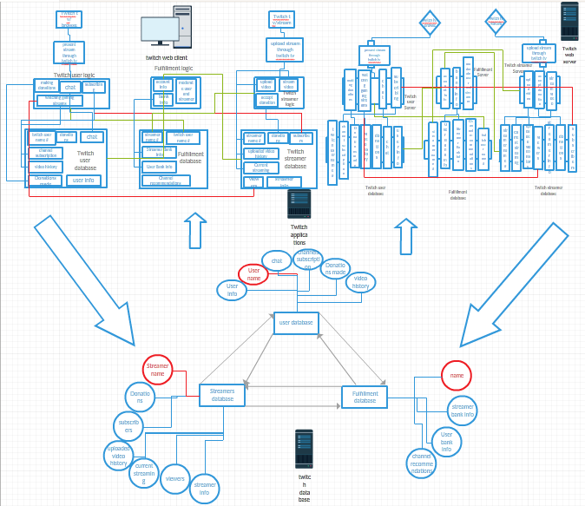

* + 1. After integrating everything we get the picture above.
    2. The client web architecture is placed in the middle of the mobile web client and the Twitch web server as it represents all the logic for it
    3. In the middle we have Twitch application server because it is the main application that speaks between the databases and the web client and web server
    4. At the bottom is the Twitch database and all of its characteristics
    5. The arrows show the path that data flows throughout the company's architectural layout. Users access Twitch in order to watch and subscribe to videos while Streamers connect in order to share their gaming content. Twitch is able to fulfill these actions by accessing their databases and managing the connection between the two parties.

# Software-Defined Infrastructure for Twitch:

## Virtualization and cloud Computing

## **Create data center use cases.**

* 1. Internal (inside the organization)
     1. Configuration management
     2. Deployment system
     3. Software provisioning
     4. Hardware provisioning
     5. Data storage system
     6. Data science infrastructure
  2. External
     1. Live video distribution systems
     2. A real-time chat system
     3. Web services that provide access to functionality and data
     4. Web application for clients
  3. Other
     1. Website development
     2. Mobile apps development
     3. High performance computing
     4. Back up videos
     5. Disaster recovery
  4. Develop a use case diagram

[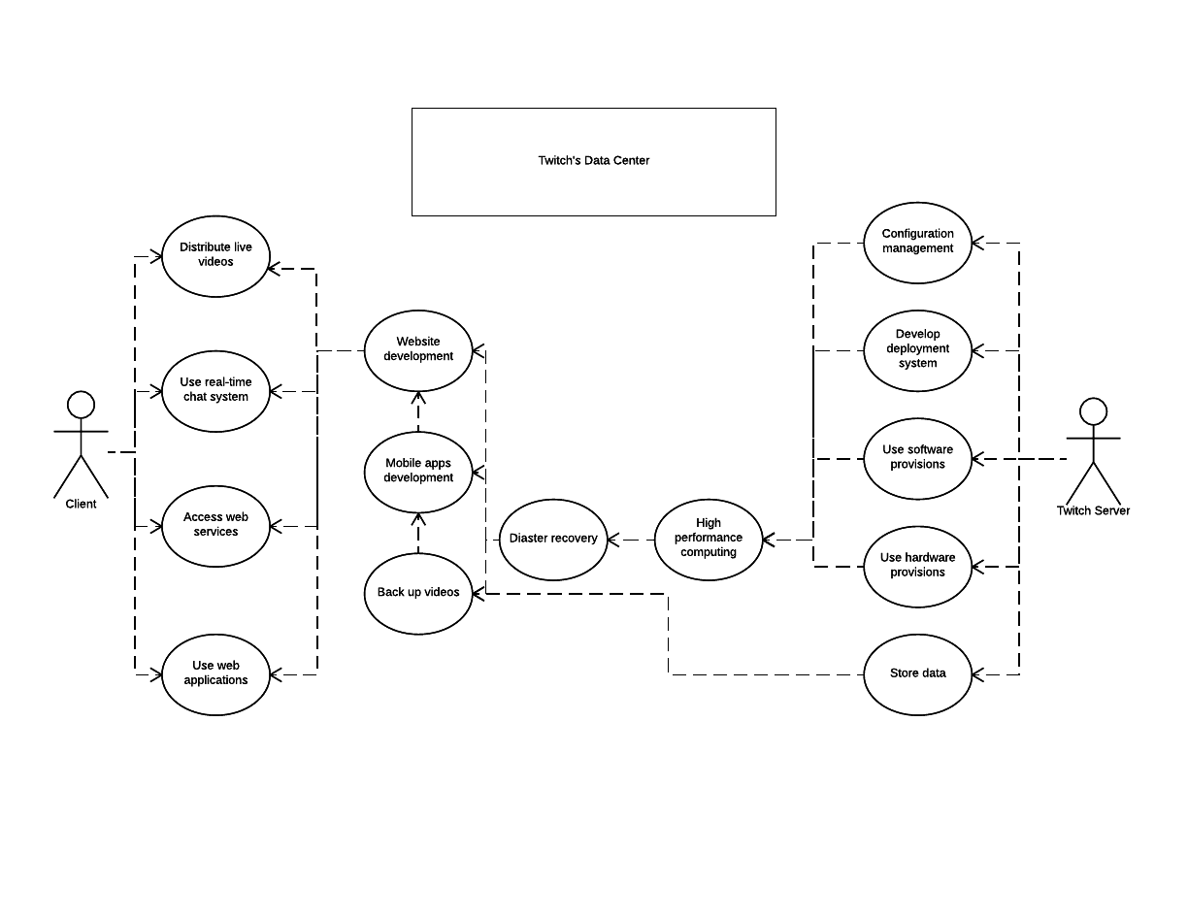](https://www.lucidchart.com/documents/edit/a738ecd3-925b-4268-a0bc-d689bdfca2b5/0?callback=close&name=docs&callback_type=back&v=2397&s=612)

Figure - Use Case Diagram for Twitch’s Virtualization

**Evaluate the current server workloads.**

Max Server Workload is 4,356 (capacity)

Average Server Workload is 3,495 (avg. workload)

Current Server Workload is 4,356/3,495 = **1.25**

1. The numbers are from <https://help.twitch.tv/customer/portal/articles/2420572>

* The number can handle the current website loading size; however, as the increasing number of Twitch users, the system still needs improvements. We decide to choose hardware emulation for virtualization,

**Select virtualization software and hosting hardware**

* 1. Choose the Virtualization technology for Twitch based on Twitch’s use-cases
     1. For Twitch, we will use the **hardware emulation** for virtualization.
     2. Hardware emulation allows each virtualized machine to run its own OS, and given that Twitch's app server and DBMS server run different languages and OSs, using hardware emulation is the best option.
  2. Design the diagram for the Virtualization at Twitch

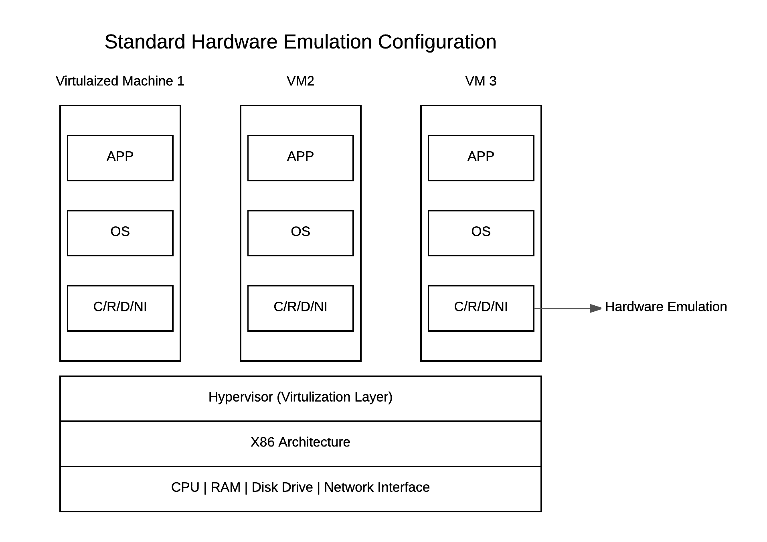

Figure - Hardware Emulation Architecture

* + 1. Hardware emulation allows each virtualized machine to run its own OS, and given that Twitch’s app server and DBMS server run different languages and OSs, using hardware emulation is the best option (architecture as illustrated above).
    2. **Given that Twitch’s current server workload is 1.25**, we need to **utilize virtualization technology to manage Twitch’s current infrastructure efficiently** so that Twitch can respond effectively to events such as a sudden change of demand.
    3. Using the Virtualization technology, we can **delegate** Twitch's servers to areas where it has the highest demand, as the **graphs illustrate below**

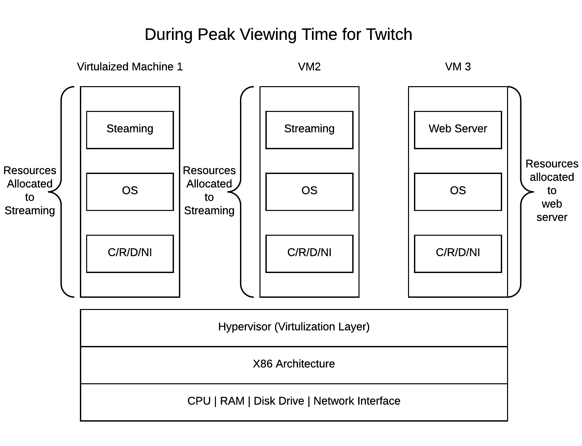

Figure - Twich’s VM(s) Allocations During Peak Viewing Time

* + - 1. **During the peak viewing time** or in the case of a sudden surge in demand, we will allocate more than half of our servers to serve streaming, allowing every user to be able to enjoy a smooth video streaming experience.

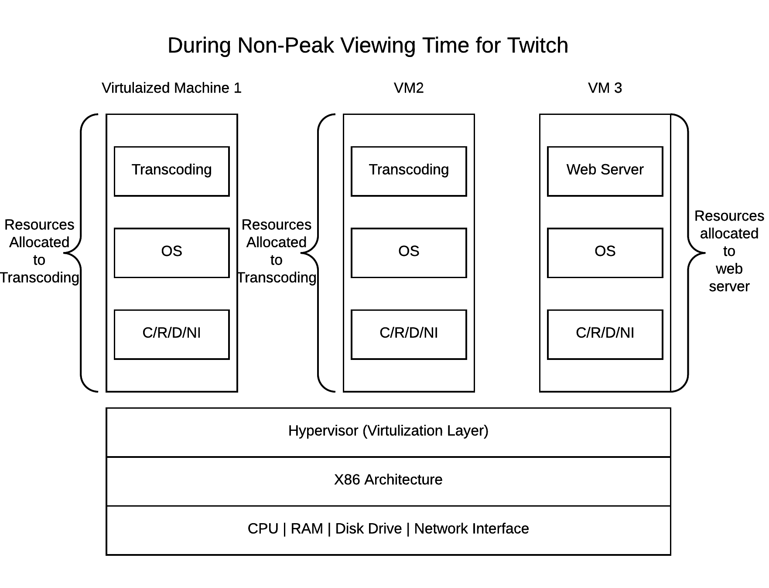

Figure - Twich’s VM(s) Allocations During Peak Viewing Time

* + - 1. **During the non-peak viewing time**, we will allocate more than half of our servers to serve transcoding or processing (optimizing) the uploaded videos, each video after a user is uploaded needs to be optimized so that it can
    1. **Put everything together in a holistic views**.

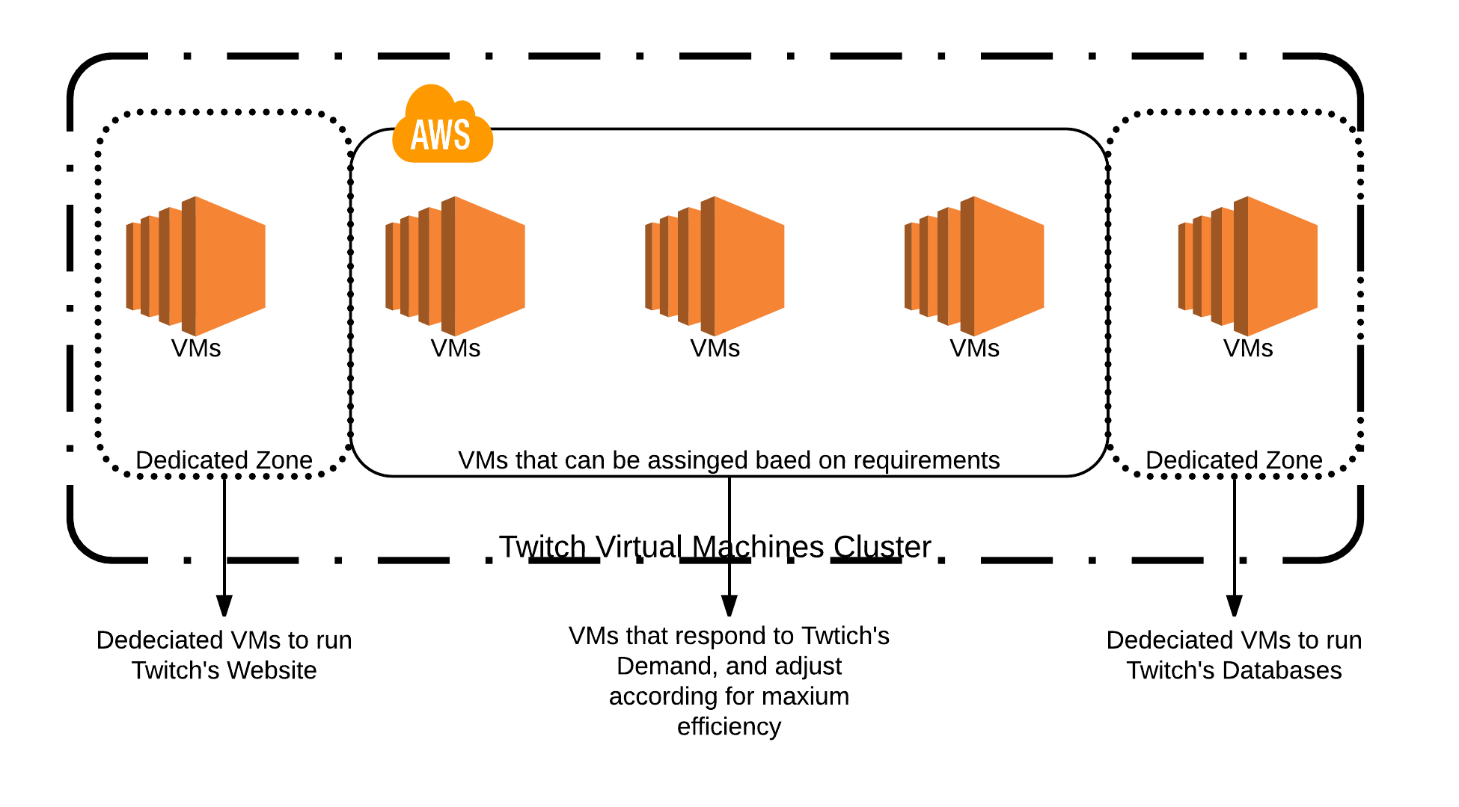

Figure - the holistic view of VM Management at Twitch

* + - 1. Above is the holistic view of how we will utilize virtualization technology to manage server resources at Twitch. **Given our server workload is only 1.25**, meaning we don’t have too much buffer to respond to a sudden surge in demand. We put some VMs together in a pool (as illustrated above) to assign them based on the Twitch's highest demand.
  1. Selecting Virtualization software and hosting hardware
     1. VMWare is the largest and most famous virtualization company. Twitch, as an Amazon subsidiary, will need to provide that reliability and performance as its parent company’s Amazon.com. Thus, we chose the VMWare’s suite of products for our virtualization needs.
     2. Products
        1. VMWare ESXi
           1. Hypervisor
           2. Abstract processors, memory, storage & other resources into multiple virtual machines
        2. VMWare vCenter
           1. Central Management system
           2. Twitch’s data center operation team can use vCenter to monitor the detailed status for all data center services
        3. VMWare vSphere Client
           1. Allows Twitch’s program engineers to access Twitch's resources using vSphere Client and access the virtual machines that are created.
     3. Since Twitch requires a massive amount of storage for videos that it is hosting, we will also use vSan to virtualize storages to ensure maximum storage capacity and durability for its video library.
     4. Diagram

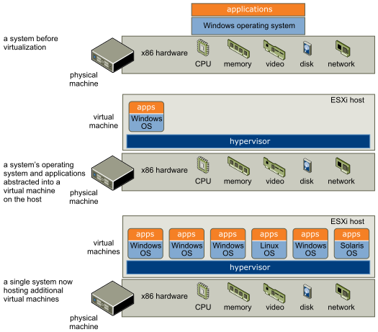

Figure - VMWare vSphere suite for Twitch’s Virtualization

* + - 1. We have selected the VMWare products that put them together in a diagram illustrated above.

**Conclude**

Using virtualization technology we can utilize Twitch's resources much more efficiently. At the same time, virtualization has the reliability built in for its storage and other machine redundancies. Twitch will benefit greatly by utilizing this technology.

**Software Defined Infrastructure (Cloud Computing) for Twitch.**

**Address the issue of hosting your data center in a Cloud Computing Environment** Address which attributes you want to host

* Storage
* Application Interface
* Server’s (Client server, mobile device, game server, app server, etc.)

Address the appropriate rational for making your choices

In order to   
 Select the appropriate cloud services option based on appropriate selection criteria

* As Stated above in problem 2, the best solution in our case is hardware emulation. In order to do this we will use VMWare to create machines that run their own OS which will run down to a main Host that will connect with to Twitch's main data server.
* vSan will be used to create cloud storage





**Conclusion:**

By making Twitch’s data center in a cloud computing environment, it would allow it to become more utilizable in the sense of accessing data faster and easier.

# Machine Learning Problem

(solved within the context of the traditional DC and/or SDI)

**Machine Learning for Twitch**

1. Machine Learning Table

|  |  |
| --- | --- |
| **Type** | **Problem** |
| Unsupervised Learning Clustering | Which games should streamers broadcast? |
| Supervised Learning Classification | Twitch Prime suggestion |
| Supervised Learning Regression | Which Channel categories, and geo location have the most views |

* 1. Which games should streamers broadcast?:
     1. We will be determining which games can increase the potential amount of viewers for each streamer based on segmented clusters.
  2. Twitch Prime Suggestion
     1. We will be determining which channels are popular based on viewing data and channel view count. We will then recommend whether they should have twitch prime or not.
  3. Which Channel categories, and geo location have the most views:
     1. Taking our known information from the general categories and the geo location of the streamers we can create a general regression of how many views it will get. By knowing how many views (our output) that each channel gets, we can refine our top problem of Twitch Prime suggestion by actively targeting Popular channels and emerging channels.

1. Machine Learning Mathematical Problem
   1. Which games should streamers broadcast?
      1. Games, Watch Time, Stream Time, Peak Viewers, Average viewers, Channel Count.
      2. Inputs: given 100 twitch users & 6 different categories
         1. $x^{i}= 1 ............... 100$ Twitch Users
 $K= Center cluster k, 1,..1...,..,K(K=4)$

 $c^{i}=$       2. center to which $x^{i}$ belongs
         3. Determine the center $u_{1},u_{2},....u_{k}$& the center $c^{i}$ associated with each twitch user $x^{i}$
   2. Twitch Prime Suggestion
      1. We have two answers for this question: “Yes” or “No”.
      2. In this case we will have 2 different probabilities:
         1. Probability that favorite count is higher than $x amount = P(F)$.
            1. This also means that the probability that favorite count is not higher than $x$ is $=1-P(F)$
         2. Probability that average rating is higher than $y amount = P(A)$
            1. This also means that the probability that average rating is not higher than $y is = 1 -P(A)$
      3. We will need to calculate the combined probability of these requirements for a Twitch prime suggestion.
 $P(F and A) = P(F)×P(A)$

     4. If $P(F and A)$ is greater than 80% then we will suggest Twitch Prime.
   3. Which channel categories, and geo location have the most views.
      1. Channel categories, geolocation → most views
      2. f: X → Y is a linear combination of input components
 $f(x)=w_{0}+w_{1}x_{1}^{}+ ........w_{d}x_{d}=w_{0}+\sum_{i=1}^{k}{}x_{1}k+\sum_{j=1}^{L}{}x2L$

        1. W = the weights of the parameters
 $x={(x}_{1},x_{2})$

           1. 2 dimensional input
            2. x = (Channel categories, geo Location)
         2. K = number of channel categories
         3. L = number of geo locations
      3. We want the weights minimizing the error
 $J_{n}=\frac{1}{n}\sum_{i=1}^{n}{}{(y_{i}-f(x_{i}))}^{2}$

 $=\frac{1}{n}\sum_{i=1}^{n}{}{(y_{i}-w^{t}x_{i})}^{2}$

    5. For the optimal set of parameters, derivatives of the error with respect to each parameter (channel recommendation and geo location) must be 0
      6. After taking the derivatives with respect to w we get
$\frac{δ}{δwj} j_{n}(w)= -\frac{2}{n}\sum_{i=1}^{n}{}{(y_{i}-w_{0}-w^{t}x_{i}.......-wdx_{i}d) x_{i},j = 0}^{}$

2. Create a step by step plan for solving each problem.
   1. Which games should streamers broadcast? (K-Means Clustering)
      1. Step 1: Collect the data and create a table of the games that each user plays.
      2. Step 2: Place the data in the 50 game space.
      3. Step 3: Create a pivot table with the following settings:
         1. Row Labels: Game
         2. Column Label: Channel Name
         3. Values: Game Count
      4. Step 4: Select the number of clusters. And add them to data data tab containing the core information.
      5. Step 5: Calculate the distance to each cluster, the minimum cluster distance, the assigned cluster, and the total distance.
      6. Step 6: Use the solver to calculate the new total distance and the cluster values.
      7. Step 7: Sort the cluster assignments in a new tab and analyze/explain the results for each cluster group.
   2. Twitch Prime Suggestion (Naive Bayes Classifier)
      1. Step 1: Determine the values for x and y.
      2. Step 2: Determine the probabilities P(F) and P(A) based on the 100 Twitch user dataset.
      3. Step 4: Make a decision on whether to suggest Twitch Prime to a Twitch User if their probability is greater than 80%.
   3. Which channel categories, and geo location have the most views?
      1. Assemble the training set
      2. Then vector features
      3. Generte a linear hypothesis that fits the data h(theta) = therta0 + ….ThetanXn
      4. Use the hypothesis to predict the output y(i) for an input feature vector x(i) i = 1,2,.... M of the training set
      5. Find and calculate the error of the predictions
      6. Sum of sqaure errors = SUM (i=1 to n) [theta^Tx ^(i) - y^(i)]^2
      7. Then we need to calculate the mean Square error
         1. 1/2m SUM (i=1 to m) [theta^Tx ^(i) - y^(i)]^2
      8. Pose two minimization problems to minimize both parameters as the solution
      9. Solve the equation to obtain the parameters that minimizes the sum of the squared errors given

**Solving the Machine LEarning for Twitch**

1. Using suitable criteria, select one of the three problems from Task III as the ML problem that you are going to solve in this Phase. Clearly define the problem you plan to solve.
   1. Channel View Count
      1. Problem: We will decide which games to suggest to streamers in order to increase viewer count.
      2. Criteria: Channel Name, game, watch time, stream time, peak views, average views, and channel count.
2. Describe the stepwise plan or approach for solving this ML problem
   1. Collect the data and create a table of the games that each user plays.
   2. Place the data in the 50 game space.
   3. Create a pivot table with the following settings:
      1. Row Labels: Game
      2. Column Label: Channel Name
      3. Values: Game Count
   4. Select the number of clusters. And add them to data data tab containing the core information.
   5. Calculate the distance to each cluster, the minimum cluster distance, assigned cluster, and total distance.
   6. Use the solver to calculate the new total distance and the cluster values.
   7. Sort the cluster assignments in a new tab and analyze/explain the results for each cluster group.
3. Implement (Execute) your plan using MS Excel.
   1. Step 1: Collect Data and create table for games/user.
      1. Below is a picture of the dataset that we pulled data from

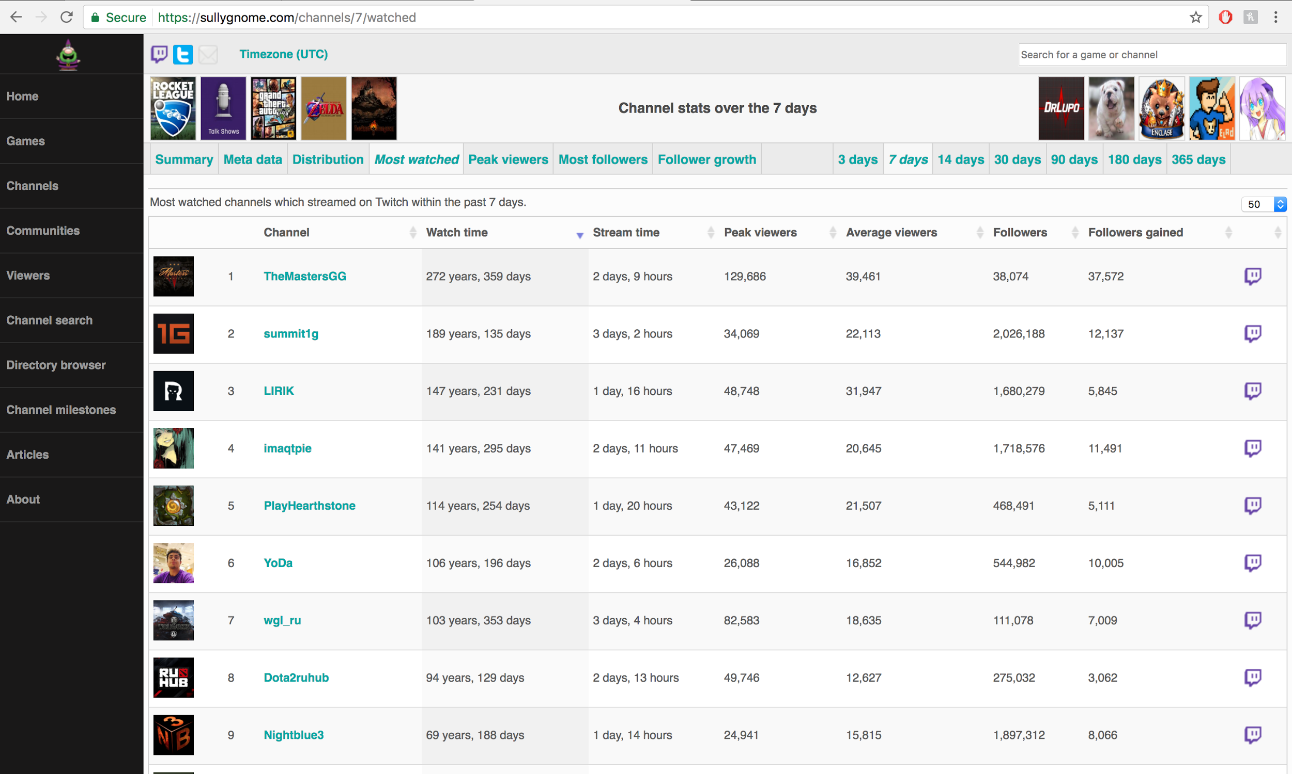

* 1. We then looked at each channel and recorded each game that they streamed the most. The resulting spreadsheet is shown below.

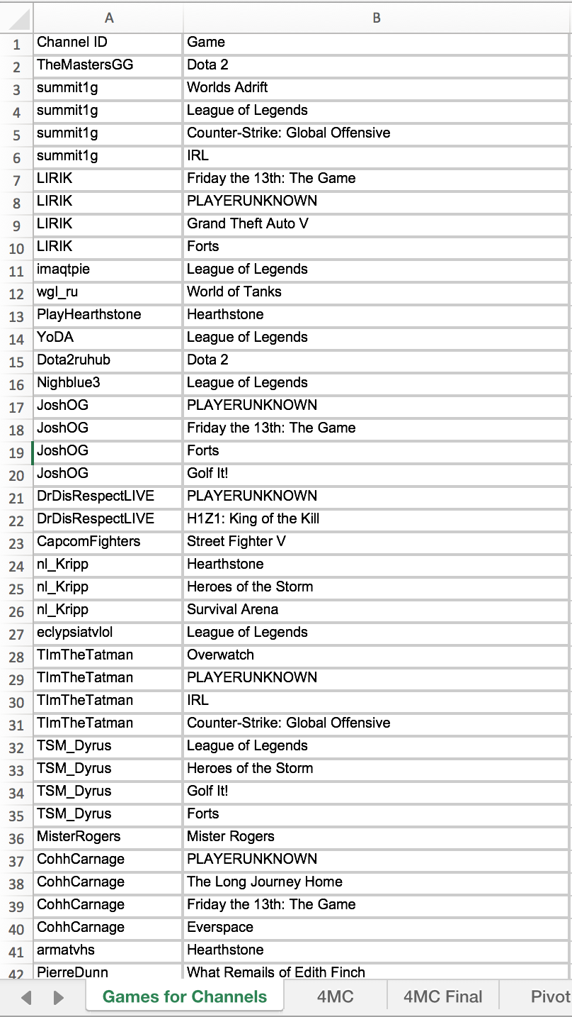

* 1. Place the data in the 50 game space.
     1. We also copied over the data from the original page shown above into another tab. This is shown below.

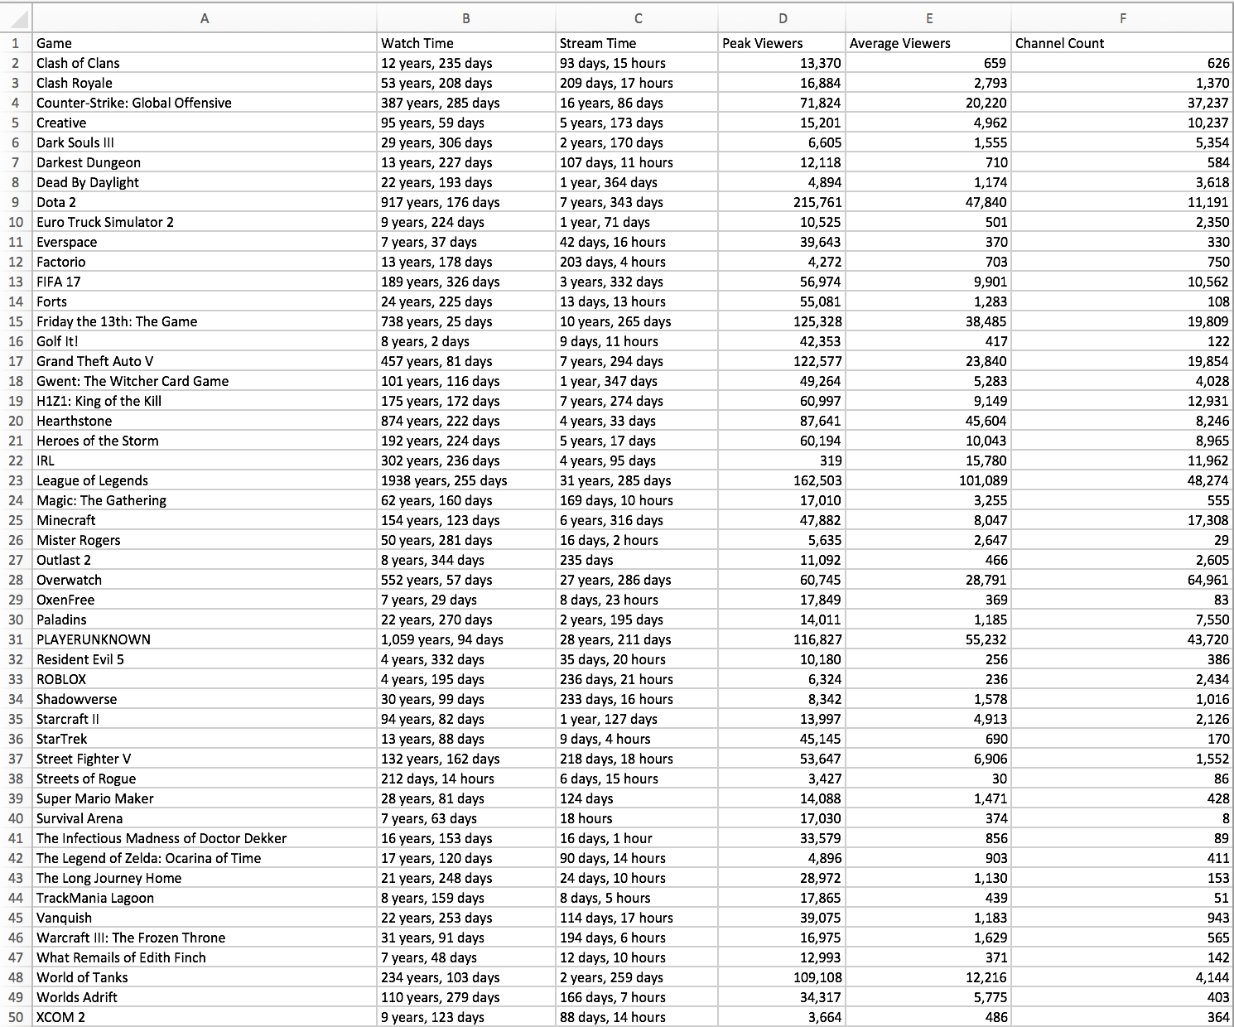

* 1. Pivot Table
     1. We then created the pivot table for the games per channel tab. The criteria for the pivottable and the end result is shown below.

Criteria

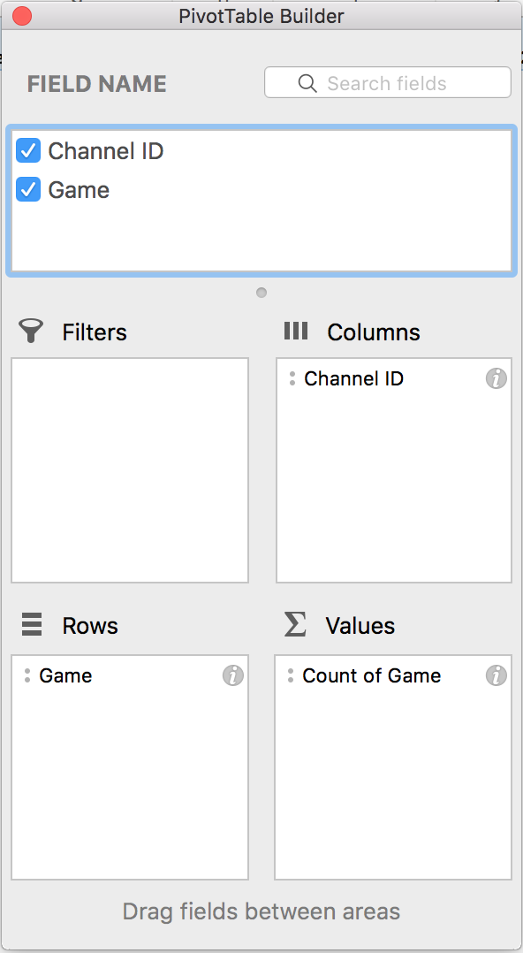

Final PivotTable

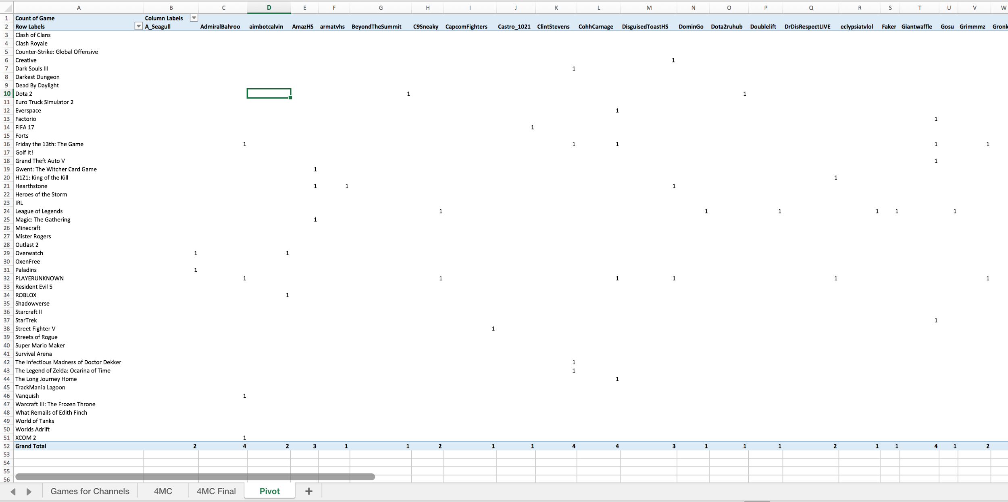

* 1. Select the number of clusters. And add them to data data tab containing the core information.
     1. We add the 4 cluster columns as shown below

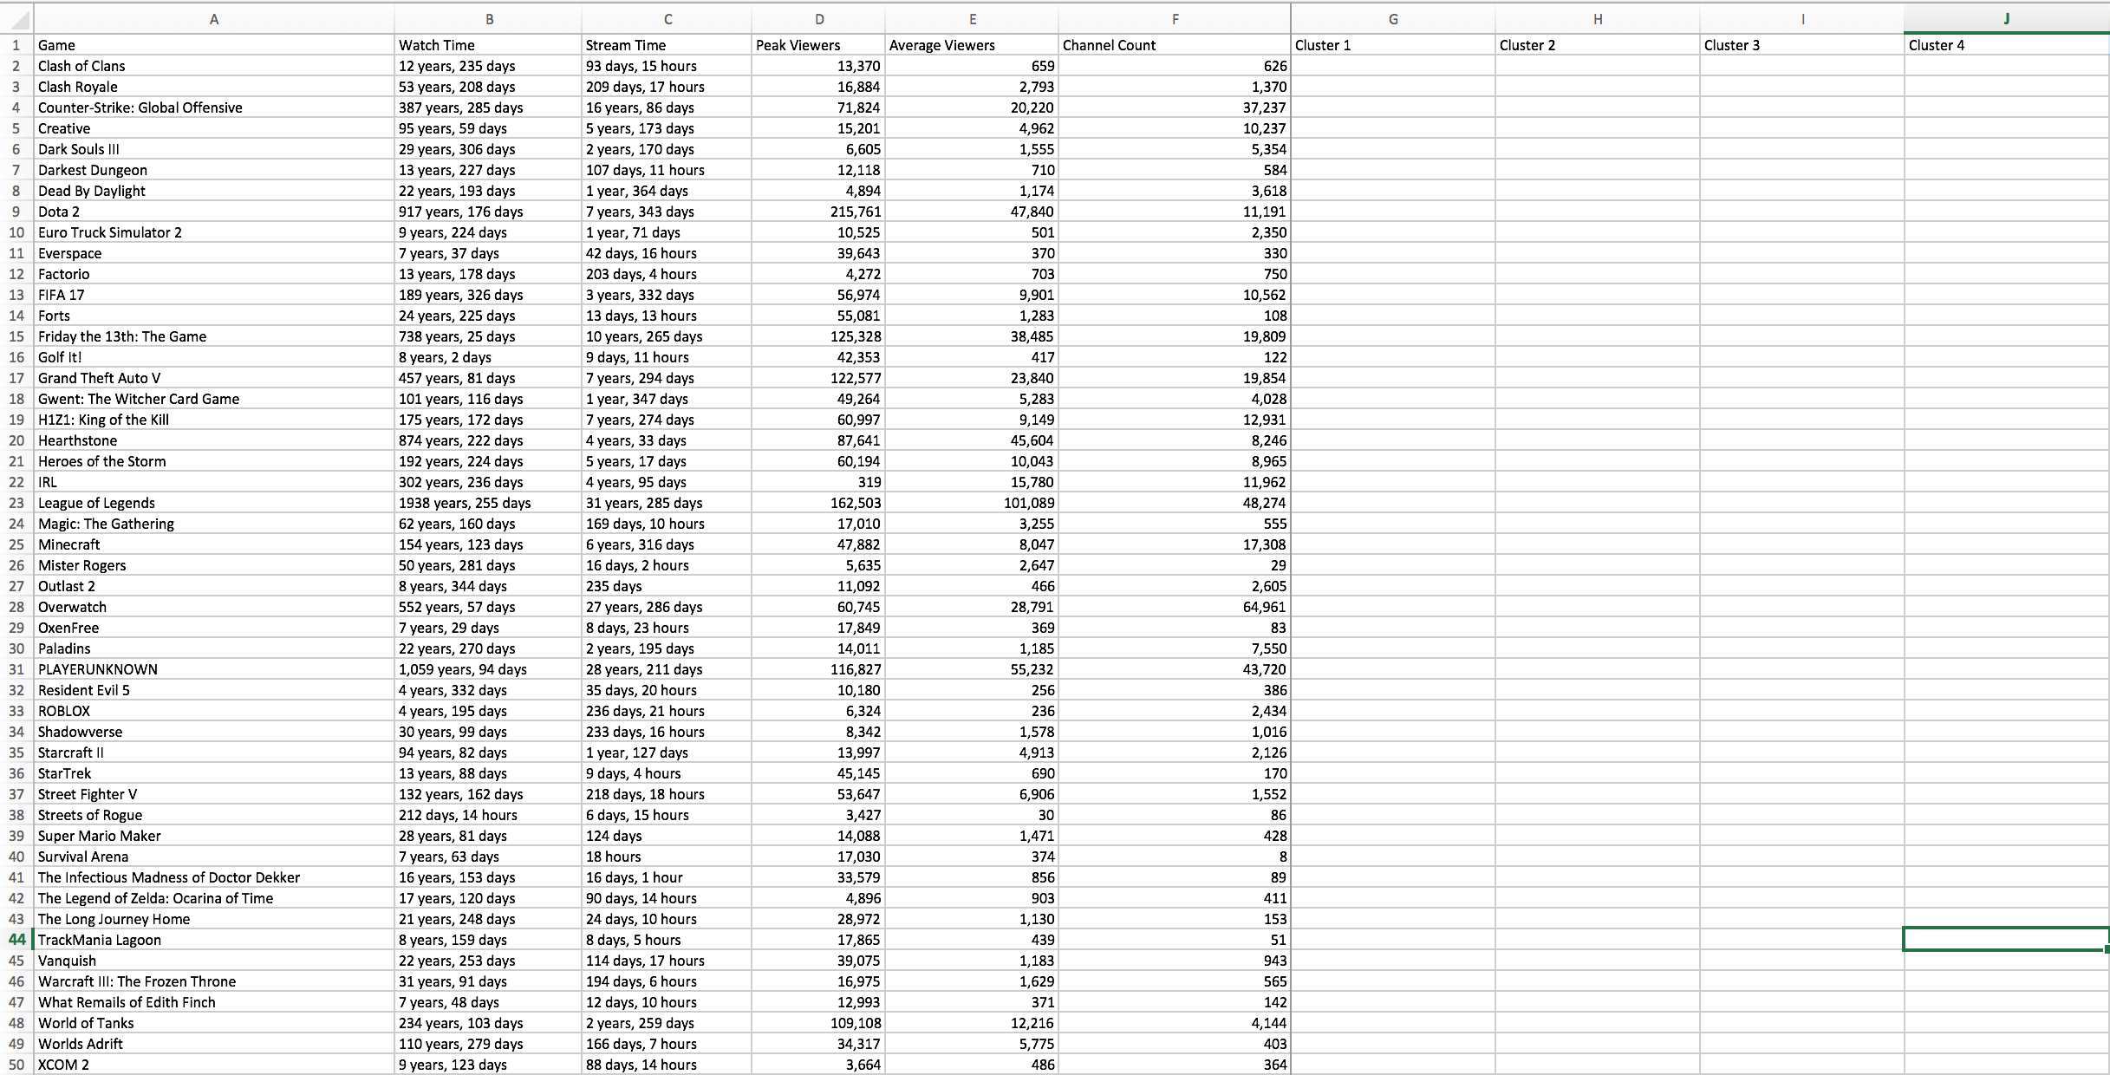

* 1. Calculate the distance to each cluster, the minimum cluster distance and the assigned cluster, and the total distance.
     1. After adding the respective equation for each of the values we have the result below.

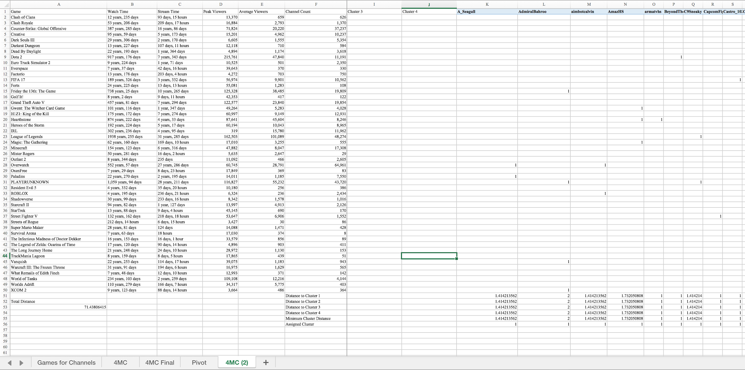

* 1. Use the solver to calculate the new total distance and the cluster values.
     1. Now we use the solver to determine the clusters for each channel. This criteria for the solver and the end result is shown below.

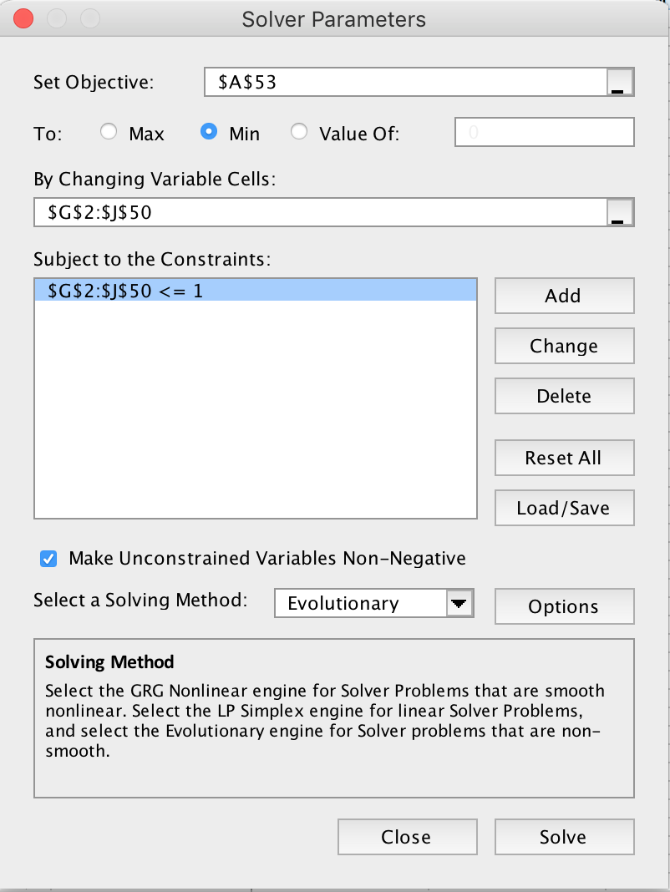

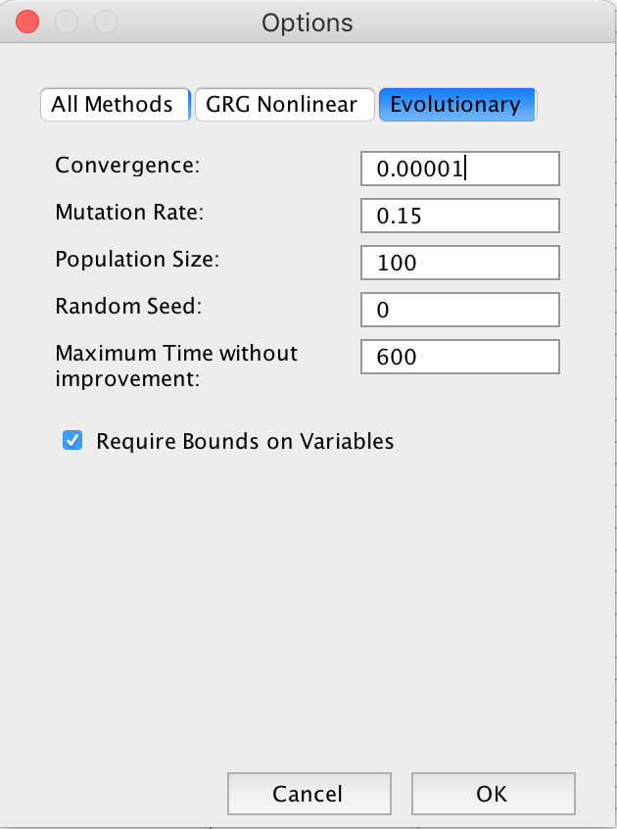

The above two picture show the criteria for the solver.

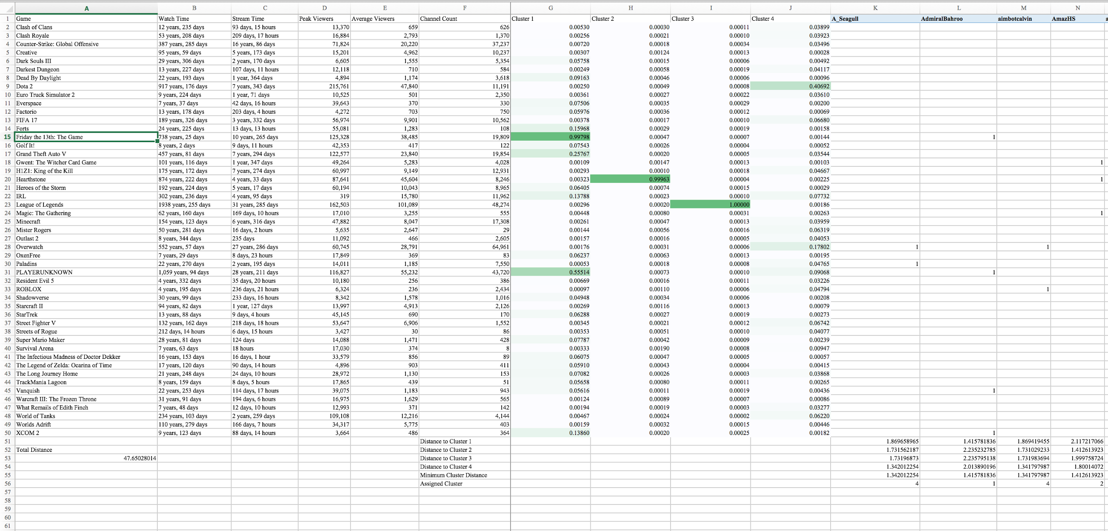

The end result gives us a total distance of 47.65.

* 1. Sort the cluster assignments in a new tab.
     1. We will now sort the clusters and explain the results of each one.

Cluster 1

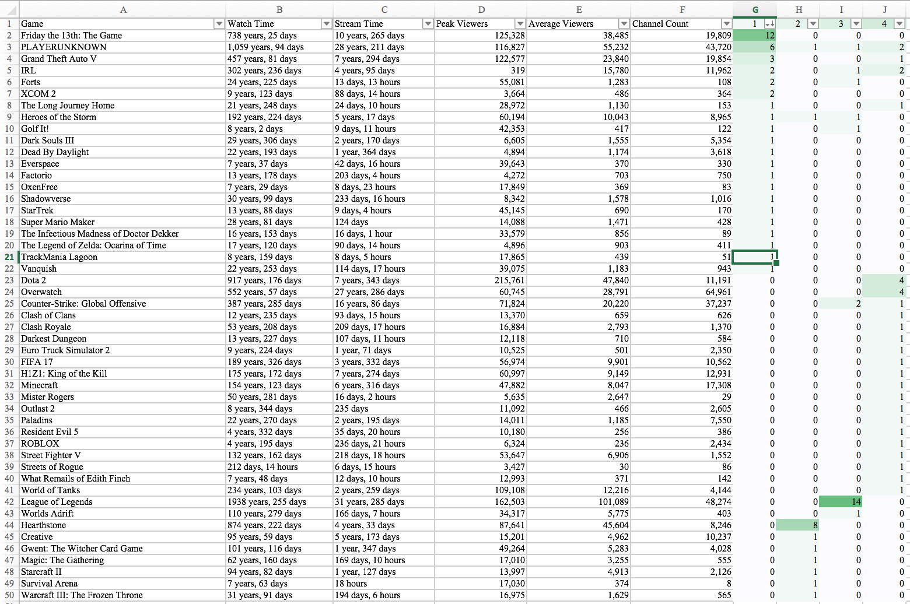

Cluster 2

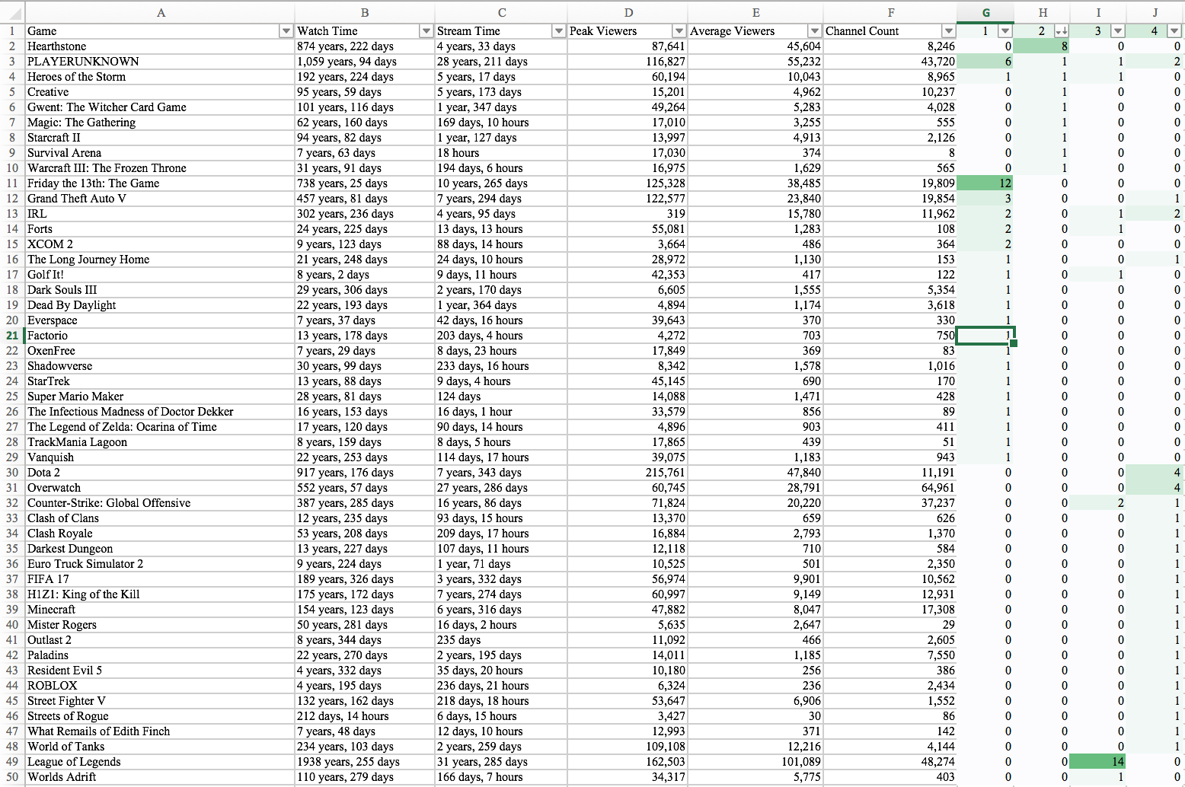

Cluster 3

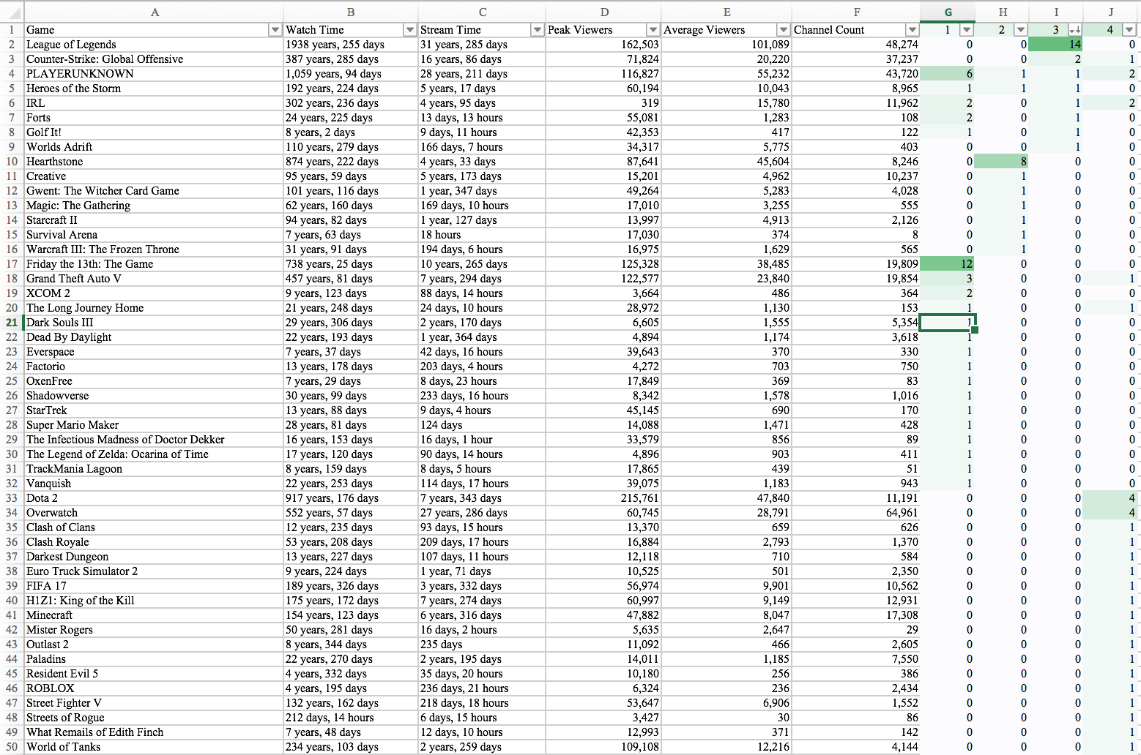

Cluster 4

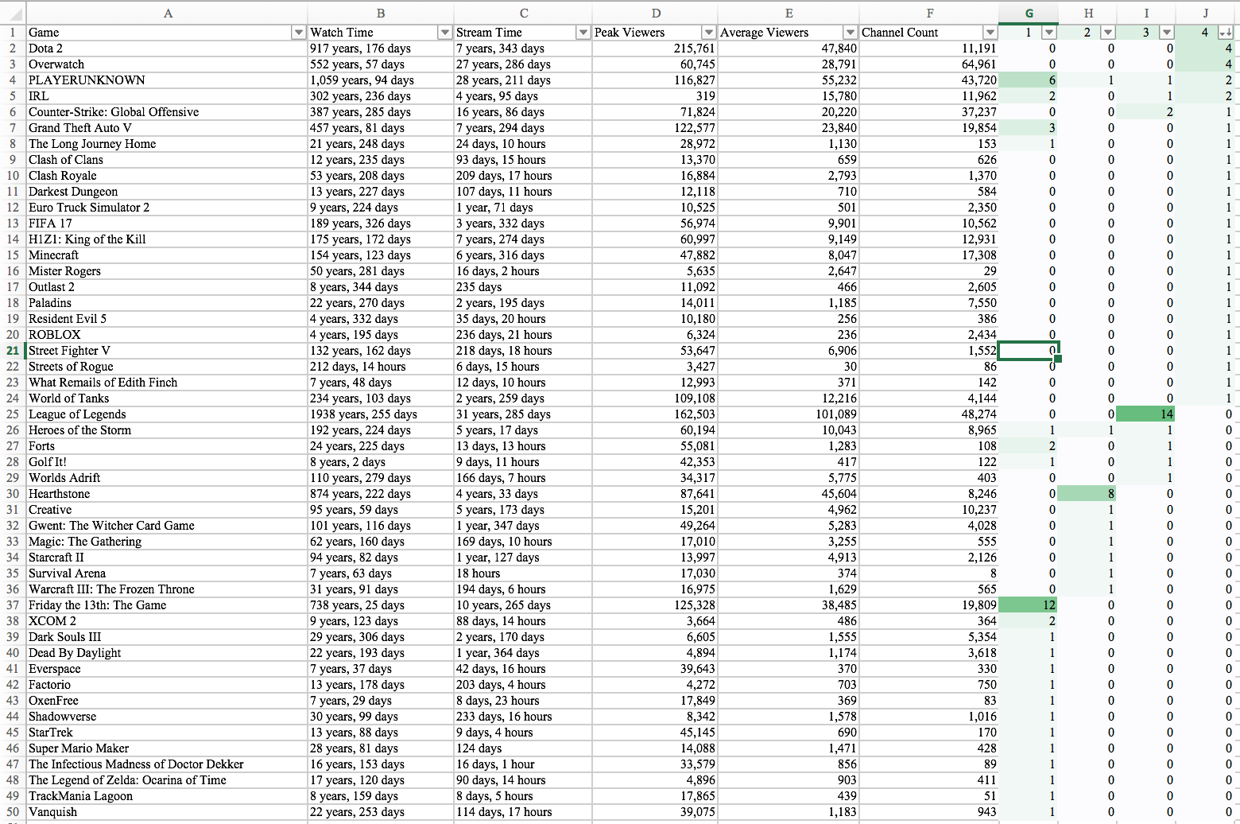

1. Clearly explain your results and how these results would be used within the organization. Clearly define the users for this ML applications, and provide a suitable use-case.
   1. Cluster 1
      1. In this cluster we can see that the most common games are Friday the 13th: The Game, PLAYERUNKNOWN, and Grand Theft Auto V. This means that streamers should stream these games in combination to increase viewer count.
   2. Cluster 2
      1. In cluster 2 we see that the streamers who focus on games like hearthstone are advised to stick with hearthstone. It seems like people who watch hearthstone streamers do not stray from that type of game. Our system would recommend them to stick with HearthStone. If they would prefer to change or add games the system would recommend them PLAYERUNKNOWN, Heroes of the Storm, and Creative. The only thing is that PLAYERUNKNOWN is very saturated but has a lot of views.
   3. Cluster 3
      1. In cluster 3 we can see that the top game is League of Legends. The next highest game Counter-Strike: Global Offensive may increase viewer count but the value is far below League of Legends.
   4. Cluster 4
      1. In cluster 4 the top four games are Dota 2, Overwatch, PLAYERUNKNOWN, and IRL. This means that streamers should stream these games in combination to increase viewer count. Dota 2 and Overwatch were the top recommendations from the system. The games have communities of people who watch that interchange, this makes it evident that if a streamer would want to increase their count, they would broaden out to those games too.

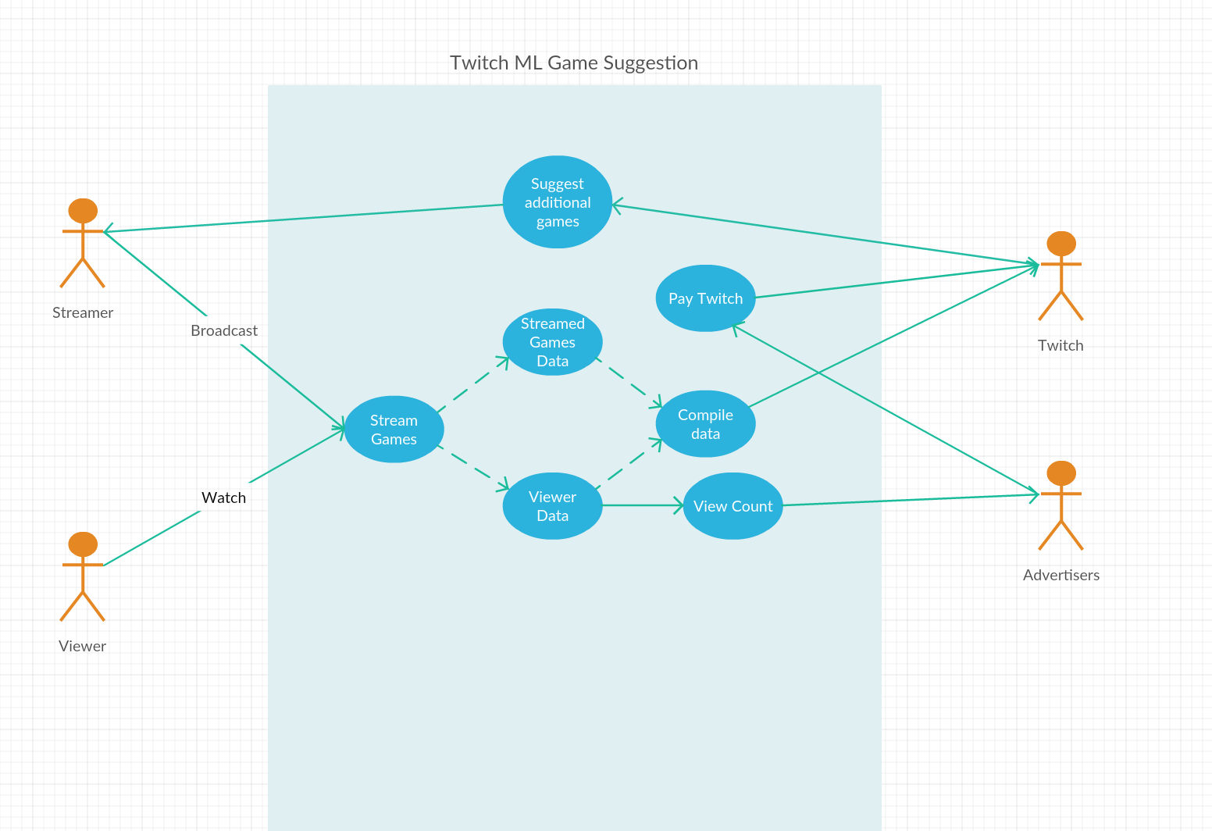

The category use case allows Twitch to select games to suggest to Twitch streamers to increase their overall views. We also included the Advertisers who receive the view count per advertisement and pay Twitch accordingly.

1. Define the software architecture for this ML application. Explore options for deploying this software using your data center architecture from Phase I (traditional) and Phase II (virtualization; cloud).
   1. Define the software architecture from Phase 1



* 1. Define the software architecture from Phase 2



* 1. Define the software architecture for the ML application
     1. Twitch AWS Building Blocks



* Tier 1 is the Infrastructure Building Blocks: it is the foundation of the AWS building blocks
  + - * + Tier 2 is the platform building blocks
        + Tier 3 is the Cross service blocks
        + Tier 4 is the tools to across services
      1. Explain the software architecture for the ML application
         1. We design the above software architecture to explain all the layers of the system. IaaS provides raw infrastructure of Twitch
         2. Tier 1 shows the database center that stores all the live streams, user information, viewer, subscribers, and donation amount
         3. Tier 2 stores the the network transmissions and payment processes.
         4. Tier 3 connects users input to Twitch ‘s main service
         5. Tier 4 presents the webpage that is available for users to use, i.e. to watch a video, to upload a video, or to subscribe a channel.

# Conclusion

Our group within Twitch thought it would be advantageous to find a way we can improve users of the service viewership. Meaning that Streamers would bring more people on the surface if they could know which games would increase their viewership and brand. To do this we took a look at the most popular streamers on our twitch website and took a large data set of different types of games played and compared the two. In the games played there were six features that we took upon ourselves to pay attention to. The six features were the total amount of time that was spent watching this specific game, the amount of time that was spent streaming the specific game, the highest peak of viewers at one time of that specific game, the average amount of viewers that view the specific games, and the final feature is the amount of channels that stream on that specific game. With all this information we were able to determine that for a combination of 4 different games which games would be the most beneficial for streamers to play to increase their popularity, ultimately increasing viewership on Twitch as a whole. For example the results we determined were that streamers who played Friday the 13th: The Game, or PLAYERUNKNOWN, or Grand Theft Auto V, would benefit from playing all three of these games. While someone who plays hearthstone would benefit from playing PLAYERUNKNOWN, Heroes of the Storm, and Creative. In cluster 3 we can see that the top game is League of Legends. The next highest game Counter-Strike: Global Offensive may increase viewer count but the value is far below League of Legends. In addition someone who plays League of Legends would benefit from playing Counter-Strike: Global Offensive.Lastly someone who plays Dota 2 would benefit from playing Overwatch, PLAYERUNKNOWN, and IRL.